
MUNICIPALITY OF MILAN
LOCAL MAPPING:
Network of social services for Adult Foreign Immigrants in the territory of Milan Municipality

"Project financed under the European Fund for Integration of Third-Country Nationals"

MILAN AT A GLANCE  POPULATION  The city of Milan has 1,306,561 inhabitants, spread over an area of 181.77 Km², with a density of 7,190 inhabitants per km². The resident population, which had been declining continuously since 2006, began to grow again during 2008 and 2009.  Although the phenomenon of demographic ageing is slowing, the most elderly component of the population continues to be larger than the youngest: for every 100 young people, in fact, there are 194 elderly people, and the percentage of elderly people comes to 23% of the total resident population.  The birth rate, at 9.63, has shown a rising trend since 2000. 37% of births occur outside marriage and the percentage of babies born to at least one foreign parent has reached 33%. |  | RESIDENT POPULATION  1,306,561  1,294,603  1,299,633  1,303,437  1,308,735  1,299,439  1,150,000  1,170,000  1,190,000  1,210,000  1,230,000  1,250,000  1,270,000  1,290,000  1,310,000  1,330,000  2004  2005  2006  2007  2008  2009  POPULATION BY AGE GROUP  (2009)  9%  MINORS  7 - 18  6%  YOUTH  19 - 25  6%  CHILDREN  0-6  23%  ELDERLY  over 65  56%  ADULTS  26 - 65
FOREIGN POPULATION  15,3%  14,0%  13,6%  13,1%  11,0%  12,4%  0%  20%  40%  60%  80%  100%  2004  2005  2006  2007  2008  2009  foreign population  Italian population  FOREIGN POPULATION BY AGE GROUP  (2009)  ELDERLY  2%  over 65  ADULTS  68%  26 - 65  YOUNG PEOPLE  8%  19 - 25  MINORS  12%  7 - 18  CHILDREN  10%  0-6 | Milan’s resident foreign population, which has increased steadily in recent years, has reached 199,372 inhabitants, who make up 15.3% of the whole population of Milan. Between 2004 and 2009 the increase recorded was 39%, and the percentage in relation to the number of residents increased by 4.3%.  The number of foreign minors who are resident in the city is 42,359, 21.25% of the entire foreign population.  HOUSEHOLDS  In 2009 the number of resident households in Milan was 680,086, with an additional 7,684 institutional households. In terms of household structure, those with one or two members are progressively increasing, reaching 50% and 24% respectively, while households with 3 or more members account for the remaining 26%.  Between 2001 and 2008 the number of marriages fell by around 21%, while conversely divorces rose by 5%. Civil marriages represent over 64% of total marriages celebrated. The average age of spouses continues to increase, having reached 38.8 for men and 35.7 for women, with a consequent decrease in the growth rate of the population.

FOREIGNERS AS A PERCENTAGE OF TOTAL  POPULATION BY AGE GROUP  (2009)  23%  19%  21%  19%  1%  0%  20%  40%  60%  80%  100%  0-6  7 - 18  19 - 25  26 - 65  over 65  Foreign population  Italian population | NUMBER OF MEMBERS PER HOUSEHOLD  2009  2 MEMBERS  24%  4 MEMBERS  9%  5 MEMBERS  2%  6 OR MORE  MEMBERS  1%  3 MEMBERS  14%  1 MEMBER  50%

Social and educational policies and their tighter integration have been identified as absolutely vital factors for Milan’s competitiveness. Great attention must be given to them, also with a view to making Expo 2015 a genuine opportunity for socio-economic growth for the entire community of the city and areas for which the city of Milan is a point of reference. | KEY VALUES AND GUIDELINES  The action, not only by the Department but the whole of the Municipal Administration, is based on clear, inalienable values of freedom, responsibility and participation.
  From values ... | ... to guidelines
  CENTRALITY OF THE INDIVIDUAL, THE FAMILY AND THE COMMUNITY | A unified response to the individual or family needs
  CENTRALITY OF THE INDIVIDUAL, THE FAMILY AND THE COMMUNITY | Autonomy as the overcoming of the logic of welfare dependency, valuing the potential of each person, family or network
  CENTRALITY OF THE INDIVIDUAL, THE FAMILY AND THE COMMUNITY | Integration of social and education policies and between the various departments with a social role: education and training, health, housing, labour, youth policies
  CENTRALITY OF THE INDIVIDUAL, THE FAMILY AND THE COMMUNITY | Freedom of choice
  CENTRALITY OF THE INDIVIDUAL, THE FAMILY AND THE COMMUNITY | Reception and legal status
  SOLIDARITY AND PARTICIPATION | Subsidiarity
  SOLIDARITY AND PARTICIPATION | Proximity, bringing services within the reach of citizens
  RESPONSIBILITY AND TRANSPARENCY | Monitoring, measuring and reporting on the effectiveness of actions

GOVERNANCE OF THE LOCAL WELFARE SYSTEM

System of responsibilities and tools of governance

MAP OF THE RESPONSIBILITIES OF THE SOCIAL AND EDUCATIONAL SYSTEM
AGENT | ROLE AND FUNCTIONS
State / Ministries of Welfare and Interior | Legislation concerning education, immigration and social welfare.  Policy-setting and definition of essential levels of assistance in the area of socio-sanitary and social services.  PoIicy-setting, planning and coordination of actions within prison facilities.  Financing of projects (FNPS, Law 285, Fondo Nazionale Lotta alla Droga -National Anti-Drug Fund-, etc.).
Region of Lombardy | In the socio-sanitary and welfare area:  - Legislation and regulation;  - Planning;  - Coordination, support and monitoring of local health authorities (ASL), local authorities, and public and accredited private organisations.  Drawing up planning guidelines for social and welfare services.  Allocation of the Fondo Nazionale Politiche Sociali (National Fund for Social Policies) and self-financing through own resources.  Establishing requirements and criteria for accreditation of units providing socio-sanitary, social welfare and socio-educational services.
Province | Training and information in the area of social policies.  It holds responsibility for secondary school facilities and with regard to sensorial disabilities.
Local Health Authority | Local healthcare and socio-sanitary planning and acquisition of socio-sanitary services from public and accredited private organisations.  Provision of socio-sanitary services through public or accredited counsellors, i Sert.T., etc.  Monitoring and control of units providing socio-sanitary, socio-educational and social welfare services.
Municipality | The Municipality is responsible for social policies.  It participates in socio-sanitary planning by offering its views, expressed by the Steering Committee, on the Planning and Coordination  Document issued by the Health and Socio-sanitary Services of the Milan Local Health Authority  It takes part in projects relating to actions provided for by legislation in the sector.  It manages – either directly or through other organisations – social, socio-sanitary and socio-educational services, and services for local municipal and equivalent-status private schools.
Accredited private subjects | Provision of social, socio-educational and socio-sanitary services in the name and on behalf of the Municipality.
Third Sector | On the basis of the principle of subsidiarity, it plays a role in identifying citizens’ needs and takes part in planning the network of  local social services (Zone Plan).  It manages activities in the social, socio-sanitary and socio-educational spheres in the name and on behalf of the Municipality.
Family associations | Participation in the planning and management of activities in the social and socio-educational sphere, including through self- and mutual help activities.

GENERAL DATA  Significant indicators | Increase in the number of households finding themselves in conditions of relative poverty: in 2009 in North Italy the number of poor was estimated to be over 1.5 million, or 5.8% of citizens  (Source: Istat, La povertà in Italia nel 2009)
GENERAL DATA  Significant indicators | Appearance of new forms of poverty connected with the current economic recession and an increase in requests for economic, housing and job-seeking assistance
GENERAL DATA  Significant indicators | Growth of the resident foreign population. Between 2001 and 2009 the number of foreign residents in Milan doubled, reaching 15.3% of the Milan population as a whole  (Source: Municipality of Milan, Statistics Department)
GENERAL DATA  Significant indicators | Poor integration of Roma and Sinti populations whose numbers in the city reached almost 5,000 in 2009. Of these, 1,455, or 363 households – 300 of whom are minors of compulsory school age, are integrated into the 12 authorised areas made available by the Municipality  (Source: Department for Adults in Difficulty)
GENERAL DATA  Significant indicators | Increase in cases of mistreatment of and violence against women. According to an ISTAT survey in 2006, in Italy one woman in three aged between 16 and 70 has been the victim of physical or sexual abuse

COMBATING SITUATIONS OF POVERTY AND MARGINALISATION AND FOSTERING A RETURN TO AUTONOMY
The Municipality aims to strengthen its actions to combat poverty, with reference to counselling and reception places, income support activities, and social and work reintegration programmes for people in need.

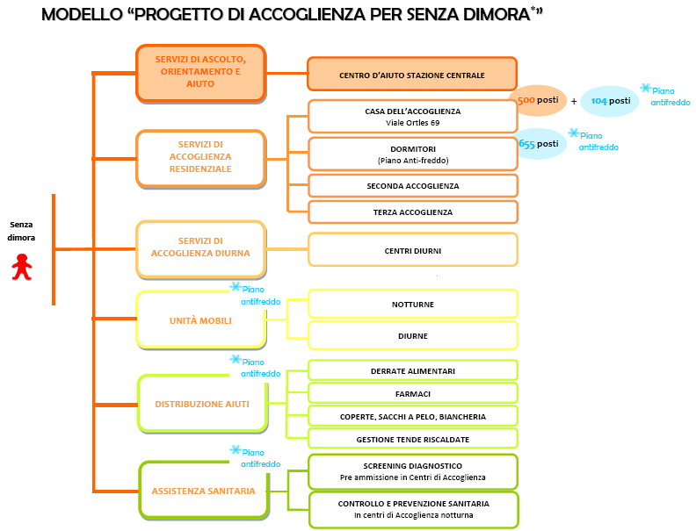
Representation of the system of services for the reception of homeless people in the Municipality of Milan
NETWORK ORGANISATIONS
Villaggio della Misericordia di Suor Teresa
Casa Silvana dei City Angels
Caritas Ambrosiana
Comunità Sant’Egidio
ORGANISATIONS ACCREDITED BY THE MUNICIPALITY OF MILAN
Milano Ristorazione
Ass. Banco alimentare
Cooperativa Universiis
Fondazione Fratelli di San Francesco d’Assisi
Centesimus Annus
Medici Volontari Italiani
Associazione La Strada
CAST
Opera Don Guanella
Ass. La cena dell’amicizia
Centro San Marco
Ass. Il Bivacco
Coop. Farsi Prossimo
Opera Cardinal Ferrari
Fondazione Exodus
Croce Rossa Italiana Comit. Provinciale di Milano
Ass. City Angels
Ass. Ronda Carità e Solidarietà
Enti partner del Progetto Diogene
Ass. Banco Farmaceutico
Istituto Villa Marelli (Ospedale Niguarda)
Homeless

COUNSELLING, GUIDANCE AND HELP SERVICES

RESIDENTIAL RECEPTION SERVICES

DAYTIME RECEPTION SERVICES

*emergency cold
weather plan
MOBILE UNITS

*emergency cold
weather plan
AID DISTRIBUTION

*emergency cold
weather plan
HEALTH ASSISTANCE

CENTRO D’AIUTO
STAZIONE CENTRALE

CASA DELL’ACCOGLIENZA 500 beds + 104 beds *emergency cold weather plan
Viale Ortles 69
DORMITORIES 655 beds *emergency cold weather plan
(Emergency cold weather plan)

SECOND-STAGE RECEPTION
THIRD-STAGE RECEPTION

DAY CENTRES

NIGHTTIME

DAYTIME

FOOD
MEDICINES
BLANKETS, SLEEPING BAGS, BEDDING
MANAGEMENT OF HEATED TENTS

DIAGNOSTIC SCREENING
Prior to admission to Reception Centres
HEALTH CHECKS AND PREVENTION
in Reception Centres

Initial assistance, nighttime hospitality and daytime reception
ACTIVITY |  |  | 2009 RESULTS
Centro Aiuto Stazione Centrale (Central Station Help Centre) (CASC) | The Centro Aiuto Stazione Centrale (Central Station Help Centre) operates in the area of severe social marginalisation, with the aim of providing guidance for Italian and foreign people who are homeless or in need in the Milan area so that they can make use of social welfare services. Specifically the service:  - provides information and guidance regarding public and private social services;  - plays an operational linking role with actions connected with the cold weather emergency (referring people to reception facilities, working with daytime and nighttime mobile units, etc.);  - refers people to second-stage reception facilities all year round;  - offers cultural and language mediation services.  Three outreach workers and a language mediator are present. Their work follows a “participatory” model with a strong educational bearing, seeking to stimulate positive attitudes during the interview, reinforcing self-esteem and setting out concrete possibilities for solving the problems that are presented, while focusing on the importance of the individual will and determination required to deal with waiting times, which are often long. |  | 14,000 people (+17% compared with 2008) turned to CASC in 2009  19,530 requests for help received  3,494 people received by municipal or accredited facilities  20 organisations involved in the social network for severe marginalisation
Mobile units | The mobile units are street-based, acting directly where their beneficiaries live. They perform initial assistance activities during evening and nighttime hours by distributing essential items. The operators of the Mobile Units develop an initial contact aimed at creating a relationship of trust, which is essential in order to foster individualised paths towards regaining autonomy.  In addition, two mobile units are active with the aim of focusing in more detail on the individual problems of people contacted during nighttime hours. |  | Coordination of 6 nighttime and 2 daytime units
 |  |  |  | FURTHER INFORMATION
PEOPLE WHO CONTACTED CASC  9,980  14,309  12,000  16,182  14,000  19,530  0  5,000  10,000  15,000  20,000  25,000  PEOPLE WHO CONTACTED CASC  (CENTRO D'AIUTO STAZIONE  CENTRALE)  REQUESTS FOR SPECIFIC HELP  REQUESTS FOR SPECIFIC HELP - 2009  8,788  7,811  976  976  392  392  195  0  1,000  2,000  3,000  4,000  5,000  6,000  7,000  8,000  9,000  10,000  WORK  ACCOMMODATION  GUIDANCE REGARDING SERVICES  GUIDANCE REGARDING  VOCATIONAL/LANGUAGE TRAINING  HEALTH ASSISTANCE  MEALS  VARIOUS |  |  |  | TO FIND OUT MORE  CASC participates in the projects of the National Poverty Observatory in railway stations. In recent years a greater degree of integration between the various actions has been achieved, thus creating a “chain” that is able to sustain personalised programmes for regaining social and financial autonomy on the part of weaker members of society and making it possible to reduce those “voids” which can lead to a decline in interest and motivation.

Initial assistance, nighttime hospitality and daytime reception
ACTIVITIES |  |  | 2009 RESULTS
Casa dell’accoglienza Ortles | The building in Viale Ortles offers temporary reception facilities for low-income individuals without any alternative accommodation together with a canteen and other medical/nursing, social and community services.  The Municipal Administration has embarked upon a significant transformation of the facility, which, over the next two years, will see the old model of the public dormitory permanently abandoned and its gradual transformation into a Multiservice Centre in favour of the adult population in need.  In addition to the services already present, such as the internal canteen, the medical/nursing service, the social service and the community services (showers, storage space for belongings, etc.), two help desks providing assistance with seeking employment and accommodation will be introduced. The transformation underway will require the involvement of outreach workers, psychologists and other social professions in order to provide actions aimed at regaining social autonomy and improving the economic situation of guests.  FACILITY IN VIALE ORTLES  7 AREAS  (500 BEDS)  1 Italian and foreign men  2 Italian men over 60  3 Italian and foreign men  4 Italian and foreign men  5 Men applying for asylum  6 Shared daytime facilities  7 Italian and foreign women  EMERGENCY COLD WEATHER PLAN  + BEDS IN BASEMENTS  (104 BEDS) |  | 827 people were received by the Casa di viale Ortles in 2009  305 personalised projects managed by social workers (+29% compared with 2008)  56 adults left the facility with an improved socio-economic situation  Concluding phase of work on the transformation of the Viale Ortles facility from public dormitory to multiservice centre for severe social marginalisation  Evening canteen  Showers  Lounge / TV / Library / Entertainment  Bag storage area, cloakroom and SHARED FACILITIES storage of personal belongings  Men applying for asylum  Infirmary and medical assistance  Social service  Daytime space

 | FURTHER INFORMATION
PEOPLE RECEIVED  827  888  927  0  200  400  600  800  1000  2007  2008  2009  PERSONALISED PROJECTS MANAGED  BY SOCIAL WORKERS  280  236  305  0  50  100  150  200  250  300  350  2007  2008  2009  PEOPLE DISCHARGED  483  655  652  56  39  41  0  100  200  300  400  500  600  700  2007  2008  2009  TOTAL NUMBER OF PEOPLE DISCHARGED  PEOPLE DISCHARGED WITH IMPROVED SOCIO-ECONOMIC SITUATION | TO FIND OUT MORE  Since October 2009 the Casa dell’Accoglienza di viale Ortles has taken part in the development of the social inclusion project for foreigners who have applied for asylum in Italy. A team of operators has been set up (1 social worker and 2 outreach workers) who promote personalised programmes of social inclusion though language and vocational education and protected employment integration with a “work bursary”. This operational model will be progressively extended to all of the facility’s guests.
TO DO MORE
The complete renovation will raise the facility’s capacity from the current 400 beds to over 500.
The transformations initiated will be further strengthened by the introduction of job and accommodation-seeking services, with the aim of:
- developing an operational model for integration between internal services and other units/organisations participating in the network;
- developing active employment policies (vocational training, career guidance, and job assistance, craft workshops, etc.) in collaboration with type B social cooperatives;
- ensuring that guests effectively remain at the facility only temporarily by seeking a different accommodation solution for each guest upon being discharged.

Initial assistance, nighttime hospitality and daytime reception
ACTIVITIES |  |  |  | 2009 RESULTS
Emergency cold weather plan |  | In the period from November to March, in order to cope with the coldest winter months, the Municipality provides extra nighttime hospitality and support services for the homeless such as nighttime and daytime mobile units, health care, and distribution of sleeping bags, food and medicines. |  | 5,050 people used the services of the Emergency Cold Weather Plan  916 beds available (+14.5% compared with 2008)  2,650 people received accommodation for the night (+5% compared with 2008)  23,691 food items, 18,187 free medicines, 984 sleeping bags and blankets and 98 bedding kits distributed
Public showers |  | In order to safeguard the personal care and hygiene of individuals who find themselves in a situation of particular difficulty and do not have access to adequate hygiene facilities, the Municipality has installed and operates 3 public shower facilities in the city. |  | 30,107 people used the service, despite the significant presence in the city of personal care and hygiene facilities provided by organisations in the Third Sector
 |  |  |  |  | FURTHER INFORMATION
 | PEOPLE USING EMERGENCY COLD  WEATHER PLAN SERVICES AND FACILITIES  4,633  4,822  5,050  0  1,000  2,000  3,000  4,000  5,000  6,000  2007  2008  2009  PEOPLE PROVIDED WITH  NIGHTTIME ACCOMMODATION  2,650  2,519  2,420  0  500  1,000  1,500  2,000  2,500  3,000  2007  2008  2009 |  |  |  | TO FIND OUT MORE  The activity of filtering access to accommodation / reception facilities is performed by the Centro Aiuto Stazione Centrale (CASC).
 | USERS OF PUBLIC SHOWER FACILITIES  48,916  34,261  30,107  0  10,000  20,000  30,000  40,000  50,000  60,000  2007  2008  2009 |  |  |  | TO KNOW MORE  In addition to the chance to use a hot shower, a kit is provided which includes shampoo, shower gel, a razor and shaving foam, a towel, toothbrush and toothpaste. A laundrette service is also available with washing machine and dryer.
TO FIND OUT MORE
The number of users of the shower facilities fell by 12% compared with 2008 thanks to increased provision of accommodation by organisations in the private social sector, for people in a situation of need and for homeless people.

Counselling and development of opportunities for autonomy in work, accommodation and relationships
ACTIVITIES |  |  | 2009 RESULTS
Ufficio adulti (Department for Adults) and Custodi Sociali (Neighbourhood Social Workers) | People who find themselves in situations of difficulty can contact the Department for Adults which offers counselling and guidance and proposes a programme of actions designed to regain autonomy. The Municipality provides temporary aid. However, the person in difficulty must take active steps to break free from social welfare circuits permanently. The services that may be activated are:  HOME CARE INTERVENTIONS  PSYCHOLOGICAL SUPPORT AND EDUCATIONAL ASSISTANCE  SOCIAL VOUCHERS from 200 to 400 euros for specific actions (home care, preparation of meals, accompanying, minor maintenance work, etc)  SUBSIDIES in the form of a monthly contribution as part of a plan agreed upon with the person concerned of up to 300 euros, a “one-off” contribution for a specific expense (health, renovation, etc,) up to 500 euros, and post-prison contribution  STUDY GRANTS, issued monthly in support of personal educational or vocational training programmes  PLACEMENT IN HOSTELS with the activation of educational assistance.  During 2008-2009 the Municipality allocated property seized from the Mafia to Third Sector organisations through a public call for applications, in order to provide temporary accommodation for households or people in difficulty and to help them regain financial and housing autonomy.  In addition to the Department for Adults, as part of a logic geared towards bringing services closer to citizens, the Municipality has extended the project of neighbourhood social and health workers, which was originally conceived in the area for the Elderly. |  | 5,293 people in total contacted the Ufficio Adulti (+6.4% compared with 2008)  177 people benefited from home care services and 60 received psychological and educational support  1,143 people benefited from financial support  12 people received study grants for personalised education programmes or vocational training  17 people benefited from accommodation in hostels  35 apartments seized from the Mafia and allocated to organisations in the Third Sector for social housing interventions  284 adults in difficulty assisted by neighbourhood social workers and socio-sanitary workers

 | FURTHER INFORMATION
BENEFICIARIES OF SERVICES AND ACTIONS PROVIDED BY  THE DEPARTMENT FOR ADULTS  37  26  27  20  14  43  60  30  34  21  19  64  177  42  36  24  12  17  0  20  40  60  80  100  120  140  160  180  200  HOME  CARE  SOCIAL  VOUCHERS  EMERGENCY  CARE  EDUCATIONAL  ASSISTANCE  STUDY  GRANTS  HOSTEL  ACCOMMODATION  2007  2008  2009  PEOPLE WHO CONTACTED  THE DEPARTMENT FOR ADULTS  4,911  4,976  5,293  0  1,000  2,000  3,000  4,000  5,000  6,000  2007  2008  2009  BENEFICIARIES OF ECONOMIC  ACTIONS  1,171  1,143  1,228  0  200  400  600  800  1,000  1,200  1,400  2007  2008  2009 | TO FIND OUT MORE  The most frequent needs of users of the Department for Adults are:  - financial help as a result of insufficient income, unemployment, or accumulated debt;  - accommodation as a result of eviction underway or already completed;  - psychological / social support for problems of loneliness, severe social marginalisation and illness.
TO DO MORE
To reinforce temporary reception services for individuals in difficulty and create a solid chain of accommodation facilities, in 2010 the Municipality plans to create, through a call for applications. 3 special lists of organisations which offer reception services within protected facilities (Emergency care, reception in small community facilities, reception in apartments) in order to identify organisations to be accredited.

Counselling and development of opportunities for autonomy in work, accommodation and relationships
ACTIVITIES |  |  | 2009 RESULTS
CELAV | Through CELAV (the Employment Intermediation Centre), the Municipality activates individual job placement programmes, giving particular attention to those individuals referred by the basic social services who as a result of situations of personal, family or social difficulty have problems integrating independently into the world of work.  Job placements take place through the activation of:  OBSERVATION PLACEMENTS, in order to identify professional skills and the employment context in which to place the person.  JOB TRAINING PLACEMENTS from 1 to 12 months in order to develop or reinforce professional skills in companies or social cooperatives accredited by the Municipality. The beneficiaries are paid € 14 a day for part-time and € 25 for full-time placements.  WORK BURSARIES, placements aimed at acquainting companies and workers with a view to prospective employment. |  | 4,078 users of CELAV (+30% compared with 2008), 471 of whom were young people  1,300 job training and orientation placements activated in 2009 (+24% compared with 2008), 28.5% for young people aged between per young people from 16 to 26.  838 people benefited from work bursaries, 32% of whom were young people  396 people were employed at the end of the placement (47% of the total)

 | FURTHER INFORMATION
USERS OF THE EMPLOYMENT INTERMEDIATION  CENTRE  4,078  3,135  2,912  0  1,000  2,000  3,000  4,000  5,000  2007  2008  2009  RECIPIENTS OF WORK BURSARIES  595  670  838  231  454  396  0  100  200  300  400  500  600  700  800  900  2007  2008  2009  RECIPIENTS OF WORK BURSARIES  EMPLOYED AT END OF PLACEMENT  JOB TRAINING AND ORIENTATION  PLACEMENTS ACTIVATED  919  1,051  1,300  0  200  400  600  800  1,000  1,200  1,400  2007  2008  2009 | TO FIND OUT MORE  By arrangement with the Cooperativa Sociale Alice 20 job placements were arranged for 16 prisoners and former prisoners in the tailoring workshop inside the prisons of San Vittore and Bollate and in the external workshop.  Through the PROMETEO project, 38 prevention, recovery and reintegration projects have been initiated for people serving sentences.  Through the PUNTO A CAPO project 257 prisoners were assisted with personalised projects and programmes aimed at guiding them towards reintegration in the local area.  20 flexible contracts were drawn up for individuals under an open prison regime thanks to a memorandum of intent with AMSA and the Superintendentship of the Prison Administration.
TO DO MORE
In addition to the projects already implemented, in order to increase the number of job placements for people in difficulty still further, the Municipality plans to institute a register of type B social cooperatives to which to entrust the provision of goods and services as provided for by Law 381/91 with regard to the employment of disadvantaged individuals referred by the municipal job placement service.

Protection and assistance for women who are victims of abuse and combating the phenomenon of prostitution
ACTIVITIES |  |  | 2009 RESULTS
Department of Initiatives against Abuse | The Department of Initiatives Against Abuse has been active since 2007, and may be contacted by women who are victims of abuse and mistreatment in order to be guided towards the network of protection and care services.  The services available include hospitality in reception centres and sheltered accommodation, guidance and legal aid for women who decide to undergo the process, organisation of self- and mutual help and psychological support, psychotherapy programmes, health care and telephone counselling.  The department also coordinates and supports projects for preventing and combating abuse and mistreatment of women, including in the area of criminal proceedings in which the Municipality takes up the victim’s case. |  | 762 actions in favour of women and 2,730 actions by the Department of Initiatives Against Abuse and other organisations
Training for police | A project coordinated by Municipality of Milan has been activated to train Carabinieri, Polizia di Stato (National Police) and Polizia Locale (Local Police) officers on the issue of mistreatment of women. The project aims to improve coordination between the various Police Forces and to reinforce shared prevention and victim protection projects, as well as to instigate cultural change with regard to the view of crimes of violence against women as a “private matter”. |  | 390 Police Officers trained  The questionnaires filled in by participants before and after the training course evidenced increased awareness of the phenomenon and the breaking down of many stereotypes connected with it being perceived as a health problem and as a social problem.

 | FURTHER INFORMATION
TYPE OF ABUSE  49%  PHYSICAL/PSYCHOLOGICAL/  ECONOMIC  6%  STALKING  11%  PSYCHOLOGICAL  17%  PHYSICAL  1%  ECONOMIC  14%  SEXUAL  2%  DATA NOT COLLECTED  PERPETRATORS OF VIOLENCE AGAINST WOMEN  250  89  22  84  26  33  14  32  21  0  50  100  150  200  250  300  HUSBAND  COHABITING PARTNER  NON-COHABITING PARTNER  EX HUSBAND/COHABITING PARTNER  FATHER  OTHER FAMILY MEMBER  UNKNOWN  OTHER UNKNOWN  OTHER | TO FIND OUT MORE  The type of abuse suffered most frequently (49%) is that involving physical, psychological and economic abuse at the same time. In 44% of cases the perpetrator of the violence is the husband.
WHO THE PROJECT IS FOR  73%  LOCAL  POLICE  1%  GUARDIA DI  FINANZA  7%  CARABINIERI  19%  NATIONAL  POLICE  67%  MEN  33%  WOMEN | TO FIND OUT MORE  The experience of the training course for the Local Milan Police, National Police and Carabinieri forces has helped to create a common language and to foster dialogue between realities that are apparently very far apart from one another: the world of voluntary work and women’s associations, the Municipality of Milan and our city’s police.

Protection and assistance for women who are victims of abuse and combating the phenomenon of prostitution
ACTIVITY |  |  | 2009 RESULTS
Protection of female victims of trafficking and combating the phenomenon of prostitution | The Municipality develops personalised programmes of care and assistance in support of women who are victims of trafficking and who wish to escape from the circuit of prostitution.  The actions that can be implemented are of the residential type (placement in accredited sheltered communities or alternative facilities identified on an ad hoc basis) and local socio-educational actions providing support and assistance (aimed at people who are independent regarding accommodation). |  | 73 victims of trafficking taken into protection in the context of specific projects  69 women helped to break free of the prostitution circuit by means of socio-educational actions

Counselling, temporary accommodation and socio-educational support
ACTIVITY |  |  | 2009 RESULTS
Linea verde droga  (Freephone drugs helpline) | A number that citizens can call for information, support, help and guidance regarding problems relating to the use and consumption of drugs. The service, which is run by arrangement with the Centro Ambrosiano di Solidarietà, relies upon professionals who also offer their support regarding matters such as the use and abuse of alcohol. On the request of those concerned, interviews can be arranged in order to provide more in-depth assistance. In addition, a specific site has been set up, www.drogaedipendenze.it, to provide new opportunities for contact with citizens and reach wider user groups. |  | Freephone number active from 9am to 8pm every day of the week  3,800 calls received in 2009
Unità multidisciplinare integrata  (Integrated Multidisciplinary Unit) | The Integrated Multidisciplinary Unit, which is promoted by the Municipality of Milan, is the service that provides a reference point in the city for prevention, counselling, support and social reintegration for all of those people who wish to escape from situations of addition or from the prostitution circuit.  The service, which is active from Monday to Friday from 9.30am to 5pm in the premises at number 6, Via Pastrengo, is managed in close collaboration with 8 Private Social Care Organisations.  The unit also offers advice and support to households and school and educational institutes that request help in managing problematic situations connected with the phenomenon of alcohol and drug consumption. |  | 99 people contacted for anti-prostitution actions, 14 of whom were taken into community protection  523 interviews offering help and support, 55 programmes of recovery from situations of addiction  918 activities with families and 656 prevention initiatives in schools

 | FURTHER INFORMATION
CALLS RECEIVED  3,808  4,041  4,487  0  1,000  2,000  3,000  4,000  5,000  2007  2008  2009 | TO FIND OUT MORE  2009 saw the trial opening of the service also on Saturdays, Sundays and weekday holidays in order to offer competent support also in situations in which people lose their usual reference points and the request for help risks going unheard. Another innovation introduced is the opportunity for parents of adolescents who contact the service to receive advice about coping with problems in their relationship with their own children, not necessarily in relation to substance abuse.
ACTIONSATMEESessed by the local area and to act as a multiplier of existing resourcesvice to receive advice about manaATMEESessed by the local area and to act as a multiplier of existing resourcesvice to receive advice about mana TO COMBAT  PROSTITUTION - 2009  99  14  8  0  20  40  60  80  100  MEN/WOMEN/  MINORS  CONTACTED  RECEPTION IN  COMMUNITY  TO EXIT CIRCUIT  LEGAL ADVICE  ACTIONS FOR PREVENTING AND COMBATING ALL  KINDS OF ADDICTION  523  55  918  656  0  100  200  300  400  500  600  700  800  900  1000  HELP AND SUPPORT  INTERVIEWS  TAKING INTO PROTECTION  AND RECOVERY PROGRAMMES  ACTIVITIES AIMED AT  FAMILY MEMBERS  PREVENTION INITIATIVES  IN SCHOOLS | TO FIND OUT MORE  With the setting up of the Integrated Multidisciplinary Unit a new organisational model has been trialled which is capable of fostering all potential synergies between Third Sector organisations and the Municipal Administration, in order to offer an integrated, non-sector-based response to the needs expressed by the local area and to act as a multiplier of existing resources.

The system of services for promoting the legal residence of foreigners in the city
ACTIVITIES |  |  | 2009 RESULTS
Immigration service | The Immigration Service, located at Via Tarvisio 13, constitutes a reference point for foreign people in the city and offers several services.  The INFORMATION DESK AND SOCIAL SECRETARIAT provides information of a legal, administrative and procedural nature regarding immigration as well as information and guidance regarding services dedicated to and accessible to immigrant citizens, including through specific publications. In addition, the Asylum Applicant and Refugee Desk situated at Via Barabino 8 offers social and legal guidance and advice to foreign citizens applying for political asylum or refugees and to staff of public and private bodies, in particular with regard to legislation concerning legal residence in Italy in connection with employment and the various kinds of residence permits.  The SOCIAL SERVICE takes into protection immigrant citizens with legal residence in Milan in conditions of severe social and relational difficulty, through temporary economic and accommodation actions, hospitality for foreigners discharged from hospitals and in situations of extreme difficulty.  The GUIDANCE AND ASSISTANCE DESK FOR FAMILY REUNION provides information regarding reunion procedures, and guidance and assistance regarding local services dedicated to foreign citizens who have just arrived.  The TRAINING AND EMPLOYMENT GUIDANCE DESK provides guidance regarding school study choices, vocational and language training courses, information regarding the recognition of qualifications gained abroad, advice regarding university access and being entered in professional registers, information regarding labour legislation and the condition of foreign workers in Italy, and assistance in preparing personalised CVs and seeking contacts for job placements.  The AWARENESS POINT FOR ASSOCIATIONS BY AND FOR IMMIGRANTS maps out and promotes awareness of associations by and for immigrants based in the city. It fosters the creation of networks between associations that are similar or have shared goals and disseminates initiatives and information of interest to associations. |  | 5,501 Italian and foreign citizens received information regarding legislation and the network of available services and actions  129 pieces of legal advice were issued by the Asylum Applicant and Refugee Desk  335 people were taken into protection by the Social Service. Of these 56% had already used the service in the past  594 actions implemented, an average of 1.8 for each user  95 social vouchers and economic contributions issued in 2009  2,091 guidance interviews regarding training and employment with 1,405 people of 92 different nationalities, with an average of 1.48 interviews per user  127 associations of foreign citizens recorded  Agreement with the ISMU Foundation to encourage the formation of professional roles that are able to organise and manage the various forms of foreigners’ associations in compliance with Italian law.

The system of services for promoting the legal residence of foreigners in the city
ACTIVITIES |  |  | 2009 RESULTS
Reception of foreign citizens discharged from hospitals | In order to receive the large number of foreign citizens discharged by hospitals but not yet self-reliant, without accommodation and family networks, The Municipal Administration offers accommodation and care at the Casa Cardinal Colombo. |  | 10 sick foreign citizens discharged from hospital taken in by the Casa Cardinal Colombo
Guidance and assistance desks for family reunion | The reunion of families with their own children constitutes a very delicate process both for those family members who are already in Italy and for those who are arriving. The Municipality offers assistance during this particular stage in the life of foreigners via the help desk situated at Via Tarvisio 13 and the 8 outlying information and guidance desks regarding procedures and taking up the most complex cases.  The activity of the desks makes it possible, among other things, to foster the total integration and permanent legal residence of foreign citizens. The networks of help desks exchange information periodically in order to monitor the phenomenon and support monthly self-help group meetings between families that have already completed successful family reunion procedures and those who have just embarked upon them. |  | Activation of 9 help desks for coordinating and monitoring family reunions  3,657 people’s cases dealt with 2,146 authorisations issued by the Prefecture between January 2009 and July 2010
Interpreting, language and cultural mediation and translations | In order to make access to services possible for the various ethnic groups of foreigners in the city who do not speak Italian and to support all of the activities carried out by the Department, the Municipality has made a team of language and cultural mediators available for 25 different languages. |  | 6,145 hours of interpreting and 1,870 hours of translation provided in 2009 for 25 different languages

 |  |  |  | FURTHER INFORMATION
SICK PEOPLE RECEIVED
20
15
10
0
10
20
30
2007
2008
2009
THE NETWORK OF HELP DESKS FOR FAMILY REUNION  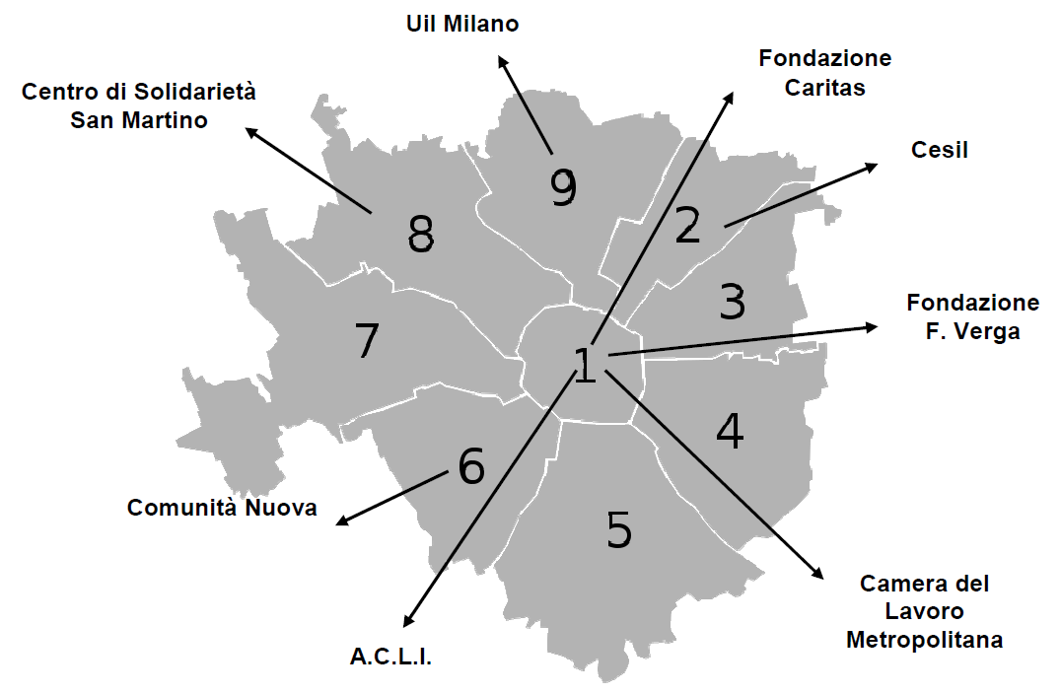 |  |  |  | TO FIND OUT MORE  49% of applications for family reunions submitted to the help desks regarded underage children, followed by applications for spouses (29%) and for parents (22%).  51 different nationalities of citizens applying for family reunion were recorded.
TO FIND OUT MORE
In 2009 a partnership was initiated between the outlying family reunion help desks and the Start Centres for the purpose of exchanging information relevant for monitoring the phenomenon, for planning and organising the placement of immigrant children in Milan’s schools, and for organising resources for receiving newly arrived citizens and distributing information material.
INTERPRETING AND TRANSLATION -HOURS  8,015  7,720  7,492  0  2,000  4,000  6,000  8,000  10,000  2007  2008  2009 |  |  |  | ! CRITICAL ASPECTS  It is necessary to develop more structured actions of language and cultural mediation in order to sustain integration in schools as well as services for families and adults in difficulty, by boosting social workers’ training in the cultural codes of the main countries of origin of users of the service.
The system of services for promoting the legal residence of foreigners in the city
ACTIVITIES |  |  | 2009 RESULTS
Social inclusion projects | During 2009 several social inclusion projects supported by the Municipality with its own resources were organised.  Some of the main ones to mention include:  MEETINGS BETWEEN CULTURES: the project, which was funded by the Ministry for Welfare and aimed at second-generation immigrants in Italy, sets out to promote a culture geared towards integration, intercultural exchange and reducing youth conflict. The project calls for the establishment of expressive workshops for both Italian and foreign adolescents aged 14-17 in Milan, and the implementation of a permanent municipal Observatory on multicultural integration among youths.  CULTURES IN COMMON: the project promotes social inclusion programmed for second-generation immigrant underage children, Italian and foreign, by valorising the local network of services and local opportunities. Starting from the needs and interests identified among young people through observation activities and focus groups, intercultural multimedia workshops (theatre, music, cinema, art and role-playing games), as well as counselling and guidance spaces, have been set up.  NIRVA NETWORK, THE PROGRAMME FOR VOLUNTARY ASSISTED REPATRIATION, which is aimed at strengthening and bringing together into a single network all of the public and private organisations that promote the voluntary assisted repatriation of specific categories of migrants, ensuring that their return to their country of origin takes place in conditions of dignity and safety, and enabling complete reintegration for them. In particular, the project is aimed at foreign citizens in situations of vulnerability who decide to return to their country of origin and are provided with support for their travelling expenses with a budget for their return.  In addition, in 2009 several social inclusion projects based on Law 40 were implemented. |  | 750 young people took part in the 25 creative expression workshops organised in 14 upper secondary educational Institutes and in other informal gathering places  The mapping of needs of young people was completed, and an atlas of resources present in the city of Milan divided by area was produced  11 voluntary assisted repatriations were arranged in 2009 in collaboration with the International Organization for Migration (OIM)  1 project by the Milan Local Health Authority and 9 projects by Third Sector Organisations

Reception programmes for asylum applicants, refugees and individuals entitled to subsidiary and humanitarian protection towards autonomy
ACTIVITIES |  |  | 2009 RESULTS
Multipurpose Centre | The Municipality offers asylum applicants, refugees and individuals eligible for subsidiary and humanitarian protection services of social and legal guidance, health care, protection, temporary accommodation and support in social and employment integration in accordance with the agreement signed by the Ministry of Interior in 2007.  The reception system consists of a Multipurpose Centre which is arranged in 6 hubs spread out across the city for carrying out reception activities and activating individual social, employment and housing integration programmes for a maximum duration of 10 months.  An ASYLUM APPLICANT is defined as a citizen who has applied for international protection and regarding whom a final decision has not yet been adopted.  A REFUGEE is defined as a citizen of a country not belonging to the European Union who owing to a well-founded fear of persecution on the grounds of race, religion, nationality, belonging to a specific social group or political opinion, is outside the country of his nationality, and is unable to or, owing to such fear, is unwilling to avail himself of the protection of that country.  A PERSON ELIGIBLE FOR SUBSIDIARY PROTECTION is defined as a person who does not qualify as a refugee but who nonetheless needs a form of protection as he would face a real risk of suffering serious harm if repatriated.  If the application for international protection is approved, the State acknowledges the STATUS OF REFUGEE OR OF SUBSIDIARY PROTECTION.  (Source: Legislative Decree no. 25 of 28 January 2008)  HUMANITARIAN PROTECTION is recognised for humanitarian reasons when, after rejection of the application of asylum it is found that it would ne dangerous in any case for the person to return to his/her country of origin.  (Source: UN, UNHCR) |  | 1,130 people benefited from 2,477 guidance interviews at the social and legal help desk  599 people benefited from 623 pieces of legal advice  62 people were taken into social care  343 individuals received with extraordinary procedures in low-threshold facilities (more than double the number in 2008)  754 individuals eligible for international protection received (+19.5% compared with 2008)  67 economic contributions and social vouchers issued for a total expenditure of 74,000 euros

Monitoring and integration of Roma families
ACTIVITIES |  |  | 2009 RESULTS
Social centre in the Roma camps | The “Piano Rom” (“Roma Plan”) has led to a far-reaching review of activities conducted with the city’s Roma and Sinti populations, particularly with regard to the settlement in Via Triboniano. The Plan provides for actions for reclamation of the local area, humanitarian aid and a census of the settled families. The Via Triboniano camp underwent an extensive reclamation action, with work on the sewerage system and connections to drinking water and electricity. In addition, a social welfare centre has been instituted in all 11 of the communal camps, with the presence of 2 outreach workers, 1 coordinator and 1 social worker, with the role of monitoring and supporting school attendance and employment integration.  11 Roma cultural facilitators have been placed both in primary schools attended by underage Roma children and within the Roma camps themselves. A service to transport pupils from the camps to schools and vice versa has been guaranteed.  During 2009 the first action geared towards reducing numbers in the camps was initiated, with the activation of the provisions set out in “Regolamento per i campi nomadi del territorio del comune di Milano” (“Regulations for gypsy camps within the Milan municipal area”) and the first actions of social integration. |  | 1 social centre activated in all 11 authorised Roma camps, with the presence of 36 professional staff  Diffusion of the “Patto di socialità e legalità” (“Agreement on social relations and lawfulness”) within all municipal Roma camps and the signing of 4 agreements in the Triboniano-Barzaghi area  273 underage children, or 91% of the total number of children of compulsory school attendance age in the fields, received ongoing attention in schools from 11 cultural facilitators of Roma origin  697 checks on income and assets carried out in 2009  25 Roma families removed from communal camps 10 helped with the acquisition of a new housing solution.

 | FURTHER INFORMATION
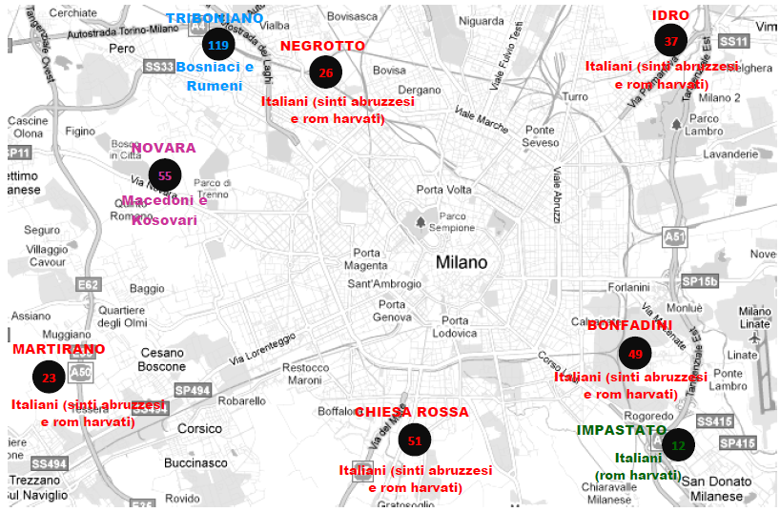  Bosniaci e Rumeni = Bosnian and Romanian  Italiani (Sinti abruzzesi e rom harvati) = Italian (Abruzzo Sinti and Harvati Roma)  Macedoni e Kosovari = Macedonian and Kosovar | TO FIND OUT MORE  Grounds for expulsion in the 2009 provisions are:  - possession of other housing (owned or rented);  - prolonged, unauthorised absences;  - definitive sentences;  - two warnings
TO DO MORE
In 2010 the “Regolamento per i campi nomadi del territorio del comune di Milano” (“Regulations for gypsy camps within the Milan municipal area”) establishes that temporary occupation is up to 1 year and may be extended to a maximum of 3, and aims to help Roma families permanently escape from a condition of marginalisation, fostering their integration into the fabric of city life and allowing the settlements to be redeveloped.

Source: Statistics Department, Municipality of Milan, population as of 31 December 2009
Source: Statistics Department, Municipality of Milan; data as of 31 December 2009
Source: Statistics Department, Municipality of Milan
? Resolution no. 2492/08 “Approvazione del progetto di accoglienza per persone Senza Fissa Dimora” (Approval of the Reception Project for Homeless People) – 01.11.2008 – 31.12.2010

