INTI PROGRAMME
European Fund for the Integration of
Third-Country Nationals Community Actions
Project: JLS/2008/EIFX/CA/1014

Healthy and Wealthy Together:
DEVELOPING COMMON EUROPEAN MODULES ON MIGRANTS HEALTH AND POVERTY



First Transnational Peer Review Workshop Report

“SENSITISING PROFESSIONALS FROM HEALTH SERVICES PROVIDERS TO MEET THE NEEDS OF MIGRANT GROUPS”

June 2010
Roquetas de Mar
Spain

« Project financed under the European Fund for Integration of Third-Country Nationals”

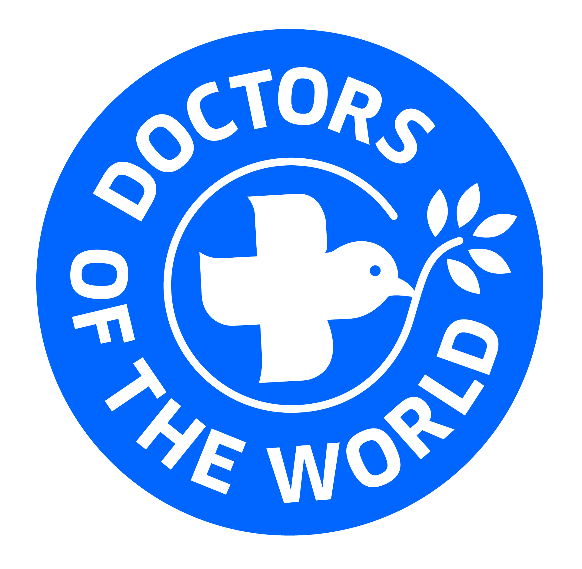
Argentina⎥ Belgium⎥ Canada⎥ France ⎥ Germany⎥ Greece⎥ Italy ⎥ Japan ⎥ Netherlands⎥ Portugal ⎥ Spain⎥ Sweden⎥ Switzerland⎥ United Kingdom

Understanding and Responding to the Healthcare Needs of Migrants
Susan Wright
Doctors of the World UK
Healthy and Wealthy Together
Qec-ERAN conference
June 11, 2010

Table of Contents
Introduction
The importance of understanding the health needs of migrants
Background and Research
Meeting the health needs of migrants – obligations and experience at the
UN and European level
Meeting the health needs of migrants – obligations and experience at the
UK level
Placing the experience of migrants in a broader context – a call for
transculturalism
Working together to meet the healthcare needs of migrants
Tool Box
Introduction
Training – focused on multicultural competence

    - Background and research

    - Sample curricula

    - Further resources

Training – focused on accessibility and flexibility

    - THINk case study

    - Doctors of the World UK training case study – spotlight on accreditation

    - Further resources

Delivery of healthcare – good practices

    - Project:London case study

    - Sandwell PCT dedicated GP practice case study

    - Hetherington Group practice case study

Development of Policy

    - UK-specific example

    - Further resources

Introduction
The importance of understanding the health needs of migrants
Patterns of migration are ever-changing, and seldom predictable. Every Member State feels the impact of migration, in ways that are potentially positive and negative. And there is a strong movement toward more unified policies relative to migration. Health is among the policy areas that require examination and thoughtful analysis as those policies are made.
Chief among the policy issues relating to the health needs of migrants is the question of access. Throughout Europe there is a great deal of variety in the level of access afforded to migrants. There are many reasons behind decisions to limit access, and it would be a mistake to generalise. But when it comes to the consequences of limited access, there are features that are key in each country.
- Lost opportunity for prevention
- Lost opportunity for early detection
- Delayed treatment means advanced progression of disease and often poorer outcomes higher costs. (e.g. antenatal care, diabetes, high blood pressure, heart disease)
- Greater chance of infections diseases spreading, with negative impact on public health.
Each of these consequences has an economic impact, in addition to considerable social impact. So it is important that they be understood and accounted for.
Background and Research
Meeting the health needs of migrants – obligations and experience at the UN and European level
Understanding the health status and needs of migrants and ethnic minorities in the European Union (EU) is crucial for several reasons. First, the right to the highest attainable health is a fundamental human right which constitutes one of the underlying values in the EU together with the principle of equity in health.
Member States thus have a number of legal obligations:
Universal Declaration of Human Rights - Article 25
“Everyone has the right to a standard of living adequate for the health and well-being of himself and of his family, including food, clothing, housing and medical care and necessary social services… “
“Motherhood and childhood are entitled to special care and assistance...”
International Covenant on Economic, Social and Cultural Rights - Article 12
“The States Parties to the present Covenant recognize the right of everyone to the enjoyment of the highest attainable standard of physical and mental health.”
International Covenant on Economic, Social and Cultural Rights - General Comment No. 14
“States are under an obligation to respect the right to health by refraining from denying or limiting equal access for all persons, including ... asylum seekers and illegal immigrants, to preventive, curative and palliative health services.”
Convention on the Rights of the Child - Article 24
“Children have the right to good quality health care – the best health care possible – to safe drinking water, nutritious food, a clean and safe environment, and information to help them stay healthy. Rich countries should help poorer countries achieve this. “
Convention on the Elimination of All Forms of Discrimination against Women - Article 12
“…States Parties shall ensure to women appropriate services in connection with pregnancy, confinement and the post-natal period, granting free services where necessary, as well as adequate nutrition during pregnancy and lactation.”
Second, Health professionals are themselves bound by certain ethical obligations which inform their actions:
WMA International Code of Medical Ethics - duties of physicians in general
- A physician shall always exercise his/her independent professional judgment and maintain the highest standards of professional conduct.
- A physician shall not allow his/her judgment to be influenced by personal profit or unfair discrimination.
- A physician shall be dedicated to providing competent medical service in full professional and moral independence, with compassion and respect for human dignity.
- A physician shall respect the rights and preferences of patients, colleagues, and other health professionals.
Third, the EU has highlighted the importance of equity, social cohesion, and growth which has put migrant and ethnic minority health on the agenda, to-wit “A Common Agenda for Integration of framework for the integration of their-country nationals”
- Two-way process
- Respect of EU basic values
- Employment
- Knowledge of host country’s language, history and institutions
- Education
- Access to institutions, goods and services, without discrimination.
- Interaction between immigrants and Member State citizens
- Inter-cultural and inter-religious dialogue
- Participation
- Indicators for measuring progress
- Access to institutions, goods and services, without discrimination.
- Interaction between immigrants and Member State citizens
- Inter-cultural and inter-religious dialogue
- Participation
- Indicators for measuring progress
Fourth, migrants and ethnic minorities make up nearly 64.1 million or 9% of the total population in the EU. Comparisons across the EU are pertinent for evidence-based health policies for migrants and ethnic minorities since member states face similar challenges pertaining to health and migration.
Although research in this arena is fairly limited, there are a few key studies to consider. Among them is a survey of self-perceived health, one of the internationally leading health indicators reflecting a person’s subjective general perception of health. Self-perceived health is a strong, independent, and reliable predictor of morbidity, healthcare utilization, and mortality. It has also been used as a proxy for health needs thus it has been suggested that self-perceived health may capture the holistic health perception, including the physical, mental, and social wellbeing using individual criteria. Self-perception helps counter some of the problems inherent in reaching conclusions about a group that is so widely heterogeneous. Migrants are heterogeneous with respect to their ethnic features, historical roots, culture, and practices concerning health. And several factors may influence the health of the minority population such as factors in the country of origin (which differ quite widely), cultural background (e.g. early life risk factors, diet); factors related to the act of migration (forced or voluntary); factors during the migration process; socioeconomic factors in the host country (e.g. poor socioeconomic conditions, loss of social status); and selection effects such as the ‘healthy migrant effect’,
Most migrants and ethnic minority groups appeared to be disadvantaged in regard to self-perceived health when compared to the overall population, even after controlling for age, sex, and socioeconomic factors. Also, migrants seem to face a ‘triple burden’ with the negative effects of ethnic minority status, low social position, and poor contextual factors. It is notable that not all minority groups showed a similar risk of poor self-perceived health, a further indicator of their heterogeneity. Disadvantaged patterns for migrants and ethnic minorities were clear, when an overall view was taken. Addressing problems relating to migrant health is essential to initiate preventive and integration efforts but it is challenging because of gaps in the databases, the heterogeneity of migrant populations, and uncertainty about the validity of instruments which are magnified as a result of language barriers. Further study is needed, and should be designed in ways that address these limitations.
Meeting the health needs of migrants – obligations and experience at the UK level
In the UK there is more research, when compared with what is available on the European-wide level. But it is notable that the research supports the conclusions referred to above, that as regards health migrants fare worse that their host country counterparts.
As the UK government has itself noted, the growing size and diversity of the proportion of the UK population who were born overseas have important implications for meeting health needs and for planning and delivering health services. As part of a commitment to reducing inequalities in access and in health outcomes, government policy has focused largely on addressing ethnic inequalities in health. Less emphasis has been placed on the possible impact for migrants of factors such as country of birth, language and length of residence and immigration status in the UK. Although there is some research focus on the health needs of specific groups of migrants, such as refugees and asylum seekers, there have been relatively few attempts to gather evidence on health outcomes, needs, care and barriers to care of broader categories of migrants, including those who come to study, to work or for family reasons, and more established groups. There is particular evidence of barriers to health care arising from restricted entitlement for some vulnerable migrants. Political concern over ‘health tourism’ negatively affects the delivery of, and access to, health care for migrants. (This is the subject of more detailed analysis hereafter)
These issues require further research and the implementation of specific policies and good practice. Alongside housing, employment and education, the health status of migrants and their access to health care are key indicators, of their ‘integration’ within receiving societies. Health is also important for other integration outcomes, such as civic participation. However, there is insufficient emphasis in mainstream health research or policy on the factors that affect health outcomes and access to health care relating to
migrant experience or status per se. By bringing together available evidence, this briefing outlines some important issues for the health of migrants in the UK today. It also suggests ways in which research, policy and practice might address barriers to health, well-being and health care in meeting the needs of migrants.
Over the past two decades there have been considerable changes relating to countries of birth, nationalities, reasons for migration, settlement patterns and legal status of people in the UK who were born abroad. However, it is important to recognise short-term fluctuations in size and diversity according to world economic and political patterns and labour market needs. The large-scale movement of labour migrants and their families from former British colonies in the Caribbean, Asia and Africa from the 1950s to the 1980s has shifted to a vastly more diverse pattern. In addition to continuing family and labour migration from former colonies, increasing numbers of people fleeing political conflicts in parts of Africa, Asia and Eastern Europe in the 1980s and 1990s sought asylum in the UK. Large numbers of people from Eastern and Central European countries also sought better work opportunities here as their countries joined the European Union (EU) in 2004 and 2007.
Migration statistics show how numbers and proportions have changed. In December 2008, the proportion of those born outside the UK stood at around 11 per cent of the resident UK population, an increase of 2 per cent since 2004. In 2008, the most common country of birth for people born outside the UK was India. Different types of migrants – job seekers, students, those who migrate for reasons of marriage and family reunion, refugees, asylum seekers, undocumented migrants and recent EU migrants – may have differing health needs (including differences in need for information) and differing entitlements to access health care. Such diversity constitutes a real challenge both for health policy makers as well as healthcare providers, in terms of service planning and delivery, particularly at a local level.
The current research evidence on the health of migrants, particularly recent migrants, is limited, especially at national level. As other member states consider policy options, there are some important lessons to be drawn from what is available in the UK. There is far greater focus on minority ethnic groups, increasing numbers of whom are born in the UK. Moreover, much of the research and administrative evidence on inequalities in health outcomes and access to care, which feeds into health policy and practice, is based on ethnicity. It does not take sufficiently into account the country of birth, date of arrival, nationality, language and immigration status of people who were not born in the UK. Where there is a mandatory requirement to collect information on ethnic group, as in hospital admissions, there was almost 86 per cent coverage of ethnicity in Hospital Episode Statistics nationally. In primary care, incentives have recently been provided to general practices to collect ethnic group data from patients. An exception lies in birth and death
registrations, which record country of birth but not ethnicity, although the recent linkage between birth certificates and hospital birth notifications means that it is now possible to analyse infant mortality by both baby’s ethnicity and mother’s country of birth.
The government’s target to reduce health inequalities (primarily measured by reduction of inequalities in infant mortality by social class and in life expectancy by area) is set out with reference to cross-cutting social determinants of health, such as child poverty, education, income, employment, housing quality and area deprivation. Ethnic group differences in health determinants and outcomes are reported, with the exception of mortality data. The recent review of ‘health inequalities in England post-2010’ does consider the complex patterning of health associated with ethnic groups in relation to the continuing evidence of a social gradient in health. However, this report has recently been criticised for not sufficiently addressing the impact of ethnic diversity and racial discrimination on health outcomes, thereby missing opportunities to influence health policy and practice towards equitable outcomes for minority ethnic populations. It is significant that in the review there was even less focus on migrants than on minority ethnic groups, possibly because the necessary ‘migration variables’ were not available. This has implications for policy and practice recommendations.
A more comprehensive collection and analysis of data is needed in order to understand whether, and why, migration factors, interacting with ethnicity and socio-demographic factors, may mean that migrants have different needs and meet with different barriers compared to minority ethnic groups. Where there has been a specific focus on the health of recent migrants, this has often been on particular groups, such as asylum seekers and refugees. Of particular concern have been:
• the physical and mental impact of conditions in countries of origin, especially where there has been experience of war;
• the physical and mental trauma of the migration and settlement processes, including isolation, loss of social status and insecurity of immigration status in the receiving society;
• greater susceptibility to infectious diseases such as tuberculosis, depending on countries of origin or transit and living conditions during and after migration.
Comparison of migrant health with minority ethnic health is linked with evidence that the health status of some migrants deteriorates over time in receiving societies. The concept of ‘acculturation’ – the adoption of norms, values and behaviours that prevail in the receiving society – has been used to explain changes in the health behaviour of migrants that have negative consequences on health outcomes in the longer term.
Examples are higher levels of smoking, including in pregnancy; lower levels of breast feeding; and diets with a higher fat content. Other accounts avoid the limitations of using models of acculturation to explain migrants’ health, particularly the uni-dimensional emphasis on changes in values, norms and beliefs and focus more on structural barriers to good health and to access to and uptake of health care in the receiving country, largely using local evidence. These barriers include:
• low income and poverty leading to a lack of a decent standard of life (such as poor nutrition);
• sub-standard and overcrowded housing in local areas of deprivation where many recent migrants live;
• poor health and safety practices in some industries employing migrants;
• lack of access to reliable transport for accessing services;
• inadequate information on how to access health services, such as immunisations and screening, and lower uptake of these compared to UK-born groups;
• lack of knowledge about or denial of entitlement to primary health care, particularly for failed asylum seekers and undocumented migrants;
• inadequate language and other support;
• cultural insensitivity on the part of some health care providers.
Importantly, some of these barriers cut across length of residence in the UK, thus having an impact on both recent migrants and established residents. This evidence should likewise be of interest to other members states since it suggests that social determinants of health play as important a part in explaining health outcomes for migrants as for minority ethnic groups, but the way in which being a migrant relates to the social gradient in health has not received the attention that has been given to ethnic inequalities.
At a time when both numbers and diversity of migrants in the UK are increasing, there is an imperative need to fully understand and address both the levels of discrimination and the consequences of restrictions imposed by immigration status in relation to access to health care, and the impact of this on health outcomes. This is highlighted in evidence on pregnant women and recent mothers among vulnerable migrants, such as failed asylum seekers, those in detention, trafficked women and undocumented migrants, who are particularly dependent on health services at this period of their lives, but have been classified as not ordinarily resident and therefore may be refused access to maternity care by health care providers. On poignant example was in the “Confidential Enquiry into Maternal Deaths (2003–2005)” which found that Black African mothers, most of whom were recent migrants (including asylum seekers and those with unclear immigration status), were more than five times more likely to die than white mothers. Limited access to antenatal care and a lack of access to translation services were both factors closely associated with mortality.

Placing the experience of migrants in a broader context – a call for transculturalism
In order to understand the limits on access, it is important to differentiate between limits placed by the law itself and limits placed by the way that law is implemented. Where the law itself limits access, there are few options but to challenge the law or advocate for a broader and more sympathetic interpretation of the law. But there are often even greater barriers put up by staff who are implementing laws that do not themselves limit access. In the UK, researchers conducting mystery shopper surveys have been told that “even if migrants are entitled to care, we have no intention of allowing it” alongside blanket statements that “Indian patients aren’t accepted here.” While it would be a mistake to assume that these attitudes are pervasive, it is clear that they are not unique. Policy decisions are made and implemented against the backdrop of broader social attitudes and concerns. European-wide surveys give us a worrying indicator of these. When asked if the country has “too many immigrants” 55% in the UK said yes, 51% in Italy said yes and 50% in Spain said yes. 30% of people surveyed said that it was “important for immigrants to come from a Christian country.”

The following slide shows the extent to which the population over-estimated the number of migrants.

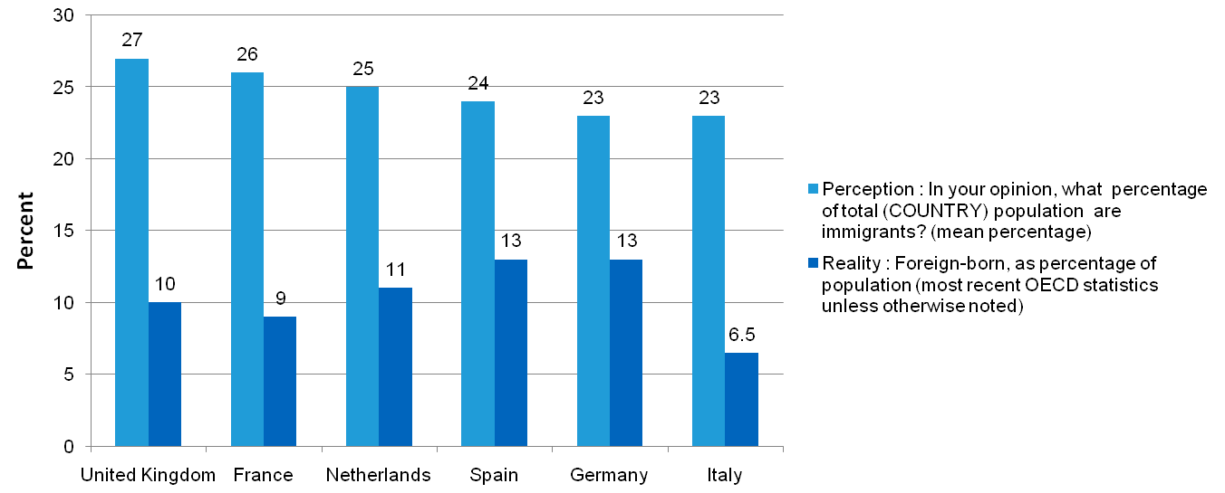

Working together to meet the healthcare needs of migrants

Now that the barriers to meeting the healthcare needs of migrants are more clear, we will focus on what is needed to overcome those barriers. What follows is a Tool Box comprised of best practices, training materials and additional resources. As an initial step toward using the Tool Box effectively, it is important to clarify the goal.
Who among the migrant population do you want to reach?
Why do you want to reach them?
Are you primarily concerned about them accessing healthcare?
Are you primarily concerned about them staying in treatment?
What barriers do you think they encounter trying to access healthcare?
What barriers do you encounter, trying to deliver healthcare?
Take the concrete example of gaps between perception and reality, and the attendant hostility that can be a barrier to migrant access to healthcare. Depending on the barriers, training might be focused on transcultural competence, « the ability to understand individual lives in terms of the particular situation and in various contexts and derive from them suitable, adapted procedures.” As a result of its complexity, it must be the subject of training followed up by skill implementation which must be the subject of reflection and where possible supported. Some key aspects, for our purposes, are as follows:
- Re-examining static and dynamic cultural understanding
- Interrogating notions of migration and integration
- Looking at links between migration and health - migration-related stressors), migration-related lives
- Interaction and communication / transcultural interpreters.
- Understanding of ethnology, sociology and psychology
- Racism and discrimination
- Religion and lifestyles
Tool Box

Introduction
Mindful of the complex nature of problems confronted by migrants, one can expect that service providers who are addressing their needs will need to have a robust and nuanced understanding, in order to meet those needs and deliver concrete results. As a first step, it is important to look at the materials and resources that are already in use. Since not all will translate effectively to every context, some adaptations will invariably be needed. But lessons can be drawn by examining the tools that others have developed.
This Tool Box includes a number of resources focused on training, delivery of care, and development of policy. It also seeks to introduce and contextualise each by providing background and reference to notable research.

Training – focused on multicultural competence

Because this group of people is so diverse, and so poorly understood, significant work must be done to address the gaps in cultural competence on behalf of those who are trying to meet their needs. Whether you choose to develop your training curriculum internally, or hire experts to do so externally, it is important to keep the following in mind:
- Training must be aimed at helping employees to adjust to the new conditions and enable them to respond more easily to needs which involve communication and contact with third-country nationals.
- Train staff on how to improve their communication skills, in order to convey willingness to provide care and support.

- Prepare staff for need to be adaptable and to convey understanding when individuals present late and as a consequence treatment becomes more urgent.
- Training of healthcare professionals in particular should cover specific problems which third-country nationals often present with, both actual and psychosomatic. Some are related to their status and living conditions (manual labour, unstable housing, cultural shock, changes in diet)

In order to maximize the usefulness of the training, you can seek to have the curriculum approved by the governing medical authority in order that continuing education credit is given to participants.

- To be most effective, the training should cover three areas, which can be delivered over a six month period lasting approximately 40 hours. The training should rely heavily on examination techniques, role plays and targeted lectures, in order to encourage creativity and individual engagement.

Checklist of good practices for incorporating multicultural competence

Written Communication Tools

- Recognition that tools must be simple in order to communicate effectively.

- Use of clear language

- Use of modest printing

- Use of photos and illustrations, rather than words

- Translation into popular languages

- Recognition that service users read different news sources, often local papers and newsletters translated into their languages. These must be identified and editors approached with sensitivity.

Face to face Communication Tools

- Recognition that interpreters must be trained on medical language, as well as administrative and bureaucratic procedures

- Recognition that administrative and medical staff need particular training on the effective use of interpreters

- Creation of friendly welcoming space, which is well lit and allows for privacy

- Offer of food or drink, in order to convey hospitality

Overcoming Cultural Gaps

- Recognition that lack of familiarity with the host country’s culture may lead to distrust.

- Commitment to building trust, in order to ensure access

- Recognition that cultural norms may make it difficult to share complete medical history

- Recognition that patients may feel that healthcare given in a hospital setting (where staff wear uniforms and there is often a higher level of formality) is superior to office based care.

Outreach

Target areas where third-country nationals are known to gather including

- markets where certain food is sold
- building sites, where day labour is common
- community centres
- churches and mosques
- internet cafes and call centres
- soup kitchens, and other drop-in centres

- Make use of the human resources you already have, focusing first on reaching out to communities known to your staff.

- Have t-shirts and ID badges so that outreach team members can identify themselves easily

- Provide adequate training on sensitivity and safety

Community Health Workers

- Many communities are well organised and primed for partnership in order to promote health.

- Community health workers can be vital links into hard to reach communities, and can help inform marginalised people about how to access healthcare.

- They can also help ensure that treatment continues, by helping to highlight the obstacles to continued care and strategizing about how to overcome them.

Input from and ownership of stakeholders
Project:London is a free London-based clinic for those who are unable to access healthcare, primarily migrants, sex workers and homeless people. The clinic was developed after an extensive needs assessment which involved a mapping exercise with input from potential service users.
The clinic now benefits from a Steering Committee made up of stakeholders, doctors, nurses, public health specialists, and lawyers. As a result of their input, the following lessons were learnt and adaptations made
Communications Material
- Should be developed with input from service users
- Should be simple and straightforward
- Should be translated into the languages that are most popular among your target population
- The vulnerability of the service users requires a high degree of sensitivity.
- Unless trust is built, the service users will be reluctant to access healthcare even when they need it badly.
- To this end, outreach and word of mouth are key
Overcoming language barriers
- Look at the particular needs of each member of staff (administrative and medical)
- Avoid using the service user’s friends and family, in order to ensure confidentiality
- Explore the benefits of using interpreting services that are not face to face
Training is key
- It must be responsive to weaknesses and gaps identified by service users
- It must be responsive to weaknesses identified by staff members (admin and medical)
- It must be targeted to the correct audience of participants

Sample curricula

The Cultural Medicine Passport: A Portfolio Documentation of the Learner’s Journey toward Culturally Responsive Care

This training curriculum is focused on doctors, who it is hoped will then be able to train other doctors using the same methodology which seeks to build awareness, knowledge and skills for culturally responsive care. Detailed instructions are provided for each session – including teaching techniques. Each session is a separate entity and each includes time for reflection. In order to ensure continuity and sustainability, there is an annual review of commitments undertaken during the training.
After the session participants should be better able to:
- Articulate strong rationale for teaching Culturally Responsive Care to own learners
- Adapt the WMMC Curriculum for Culturally Responsive Health Care to own setting
- Discuss the role of reflection and use of journals in a cultural competence curriculum
- Use a “passport” or other form of journaling in tracking and assessing culturally responsive care in the context of the ACGME competencies

Full PowerPoint presentation accessible at
http://webcache.googleusercontent.com/search?q=cache:iQ4hsD93HSkJ:www.fmdrl.org/index.cfm%3Fevent%3Dc.getAttachment%26riid%3D4557+culturally+responsive+health+care+(Ring+et+al&cd=2&hl=en&ct=clnk&gl=uk

Further resources

COA 360°
The COA 360° is a multidimensional cultural competency tool that evaluates the readiness of a healthcare organization, or unit within an organization, to meet the needs of a rapidly diversifying U.S. population. Developed and scientifically validated by Johns Hopkins researchers, its advantage is that it provides a “360-degree view” of the institution from the perspective of its administrators, healthcare providers, non-provider staff, and patients, rather than focusing on a single health care provider, as is the case with most cultural competency tools available today.
Accessible at http://www.coa360.org/

“Transcultural understanding”
These sites have training materials available in Italian and German:
http://www.migesplus.ch/
http://www.transkulturelle-kompetenz.ch/index2.php?m=2&nm=100

“How to modify health promotion interventions to meet the needs of ethnic minorities”

Researchers assess the range of theoretically possible approaches to culturally adapting health promotion interventions and produce an evidence-based multi-dimensional framework that could be utilised for designing future health promotion initiatives; identify further gaps in the evidence base and thereby outline where future primary research needs to be undertaken in this area, and to prioritise this work.
Accessible at: http://www.chs.med.ed.ac.uk/ethnicity-and-health/

Websites with a range of research tools and/or databases:
Diversity Rx
http://www.diversityrxconference.org/

University of Edinburgh Health Services
http://www.chs.med.ed.ac.uk

South Asian Health Foundation
http://www.sahf.org.uk

World Congress of Epidemiology 2011
http://www.epidemiology2011.com/

Training – focused on accessibility and flexibility

Background and research - cover cultural relativities inherent in the provision of health care (with an emphasis on women and the elderly) and the development of communication skills.

cover health problems related to the psychological trauma of immigration, the culture shock resulting from living in a different and unfamiliar environment and health problems immigrants might present as a result of their living conditions.

Training Materials – spotlight on accessibility and flexibility
This training is designed to be flexible to the needs of each service user. Each workshop includes a minimum of three individual activities which can be carried out on their own or as a package.

OUTLINE

By the end of this workshop the learner will be able to:

- Identify what health means to them
- Identify potential problems accessing healthcare
- Obtain access to healthcare
- Identify consequences of not having access to healthcare

CORE ACTIVITIES

Activity Title | Outcome reference | Time
What health means to you | 1.0 | 10 minutes
Problems accessing healthcare | 2.0 | 15 minutes
Obtaining access to healthcare | 2.0, 3.0 | 15 minutes
The consequences of not accessing healthcare | 4.0 | 5 minutes
Summary |  | 15 minutes
TOTAL DURATION |  | 1 hour


What health means to me

OUTLINE

Key learning objective
- Each learner to identify what health means to them

MATERIALS

To run this activity you will need:

- Appendix 1(one copy of the spider diagram per learner)  - Pens (one per learner) | - Flipchart and flipchart pen

INSTRUCTIONS

Give one copy of appendix 1 to each learner. Instruct them to each write and/or draw what health means to them on the spider diagram they have been given. Stress that there are no ‘right’ and ‘wrong’ answers.

Gather the learners back together and lead feedback, writing one or two answers from each learner on the flipchart.

Ask the group to name health services. Write these up on the flipchart. If necessary, prompt the group to contribute dentist, doctors, the emergency services and pharmacies.

LEARNER CENTRED FOCUS

Before starting the activity you should consider how the ability, literacy and learning style of those present. In particular you might want to consider:

- How you explain the activity 2) How you check participants’ understanding

RUNNING TIME 10 mins

APPENDIX 1

Health

Identify problems accessing healthcare

OUTLINE

Key learning objective
- To identify potential problems accessing healthcare

MATERIALS

To run this activity you will need:
- Flipchart and flipchart pen

INSTRUCTIONS

Gather the learners together and ask them for ideas about problems they could have with health services. Stress that you are looking for general problems not personal ones. Write about ten responses on the flipchart.

LEARNER CENTRED FOCUS

Before starting the activity you should consider how the ability, literacy and learning style of those present. In particular you might want to consider:
How you explain the activity

How you check their understanding
Get the learners to explain what they are going to do before they do it.

RUNNING TIME 15 mins

Obtaining access to healthcare

OUTLINE

Key learning objective
- To increase knowledge of how to access healthcare

MATERIALS

To run this activity you will need:

- Document which uses clear language to explain the process of accessing healthcare
- Document which uses clear language to list the documents that need to be filled out, in order to access healthcare
- Document which uses clear language to list the documents which the learner must produce, in order to access healthcare (e.g. proof of identification)
- Index cards for learners

INSTRUCTIONS

Split the group into smaller groups of three or four learners. Assign them roles, in order that they can role play between a person trying to get access to healthcare and a frontline staff trying to ensure that rules are followed.

Ask groups to recount the process, describing what difficulties they encountered and how they overcome them.

LEARNER CENTRED FOCUS

Before starting the activity you should consider how the ability, literacy and learning style of those present. In particular you might want to consider:

How you explain the activity

How you check their understanding
Get the learners to explain what they are going to do before they do it.

RUNNING TIME 15 mins

Consequences of not
Accessing healthcare

OUTLINE

Key learning objective
- To increase awareness of the consequences of not being registered with health services.

MATERIALS

To run this activity you will need:
- Flipchart and flipchart pen

INSTRUCTIONS

Gather the learners together and ask for ideas about what they could do if they became sick and had not made arrangements to be able to access healthcare. Write ten answers on the flipchart.

Ensure that the ensuing discussion includes taking note of the fact that this could lead to delays in treatment or resorting to emergency services.

LEARNER CENTRED FOCUS

Before starting the activity you should consider how the ability, literacy and learning style of those present. In particular you might want to consider:

How you explain the activity

How you check their understanding
Get the learners to explain what they are going to do before they do it.

RUNNING TIME 5 mins

Spanish case study

An obvious and often insurmountable barrier to ensuring that services are both accessible and flexible is lack of adequate funding for the programming and monitoring of those services. There are, however, examples of governments which have set aside funds which can be accessed for these purposes. The UK government has dedicated significant resources to a Migrant Impact Fund, although it is unclear whether the government which took power in May 2010 will continue it, and if so at what level of funding. A better examples is the Social Integration Fund in Spain, which was initiated in 2005 and has been renewed several times since then.
City, country | Spain
Organization | Spanish government
Title of the project | Social Integration Fund (Fondo de Acogia e Integracion)
Source of funding | The fund is funded annually as part of the national budget, and it has increased from 120 million euros in 2005 to 200 million euros in 2009
Short description of the program | The Spanish government in 2005 created a Social Integration Fund (Fondo de Acogia e Integración) to provide grants to autonomous communities to support immigrant integration in the areas of education, social services, employment services, housing, health care, civic participation, gender equality, and community awareness.  Autonomous communities must re-grant at least 40 percent of the funds received from the central government to municipalities, but only those where foreigners account for at least 5 percent of the total population are eligible.. Grants are allocated to autonomous communities based on the number of resident, working, and educated third-country nationals. There are additional criteria based on some special situations — such as supplemental grants to autonomous communities with particularly large arrivals or large numbers of unaccompanied minor immigrants.
Website | http://www.juntadeandalucia.es/empleo/www/pmigratorias/fondo_apoyo_2005.php?nav=1&valnav=28&idreg=264?nav=1&valnav=28&idreg=288

THINk case study

There are several strong approaches to community engagement, focused on improving access to health services among hard to reach populations whose voices are seldom heard. THINk is one example:
City, country | London, United Kingdom
Organization | THINk
Title of the project | THINk to engage
Contact details | consultation@towerhamlets.gov.uk  +44 20 7364 4572
Funding details | Funding is provided by the UK government through the Working Neighborhoods Fund. As part of a concerted drive to get people off welfare and into training and work the Government established a new Working Neighbourhoods Fund which focuses on the most deprived areas and which will support local authorities and communities in their efforts to tackle worklessness and the other elements of deprivation.
Short description of the program | One excellent example of community engagement is THINk, the Local Involvement Network, or LINk, for Tower Hamlets. LINks have been set up in every area of England, funded by the government and supported by an independent organisation, known as a Host. THINk is a network of more than 600 local people and groups who believe that the users of local health and social care services often have the best ideas on how they can be improved. Their role is to gather those ideas and make sure that they are considered when services are being designed or their performance is being assessed.  What does THINk do?  - Promote and support the involvement of people in the commissioning, provision and scrutiny of local care services.  - Obtain the views of local people about their needs for, and their experiences of, local care services.  - Enable local people to monitor and review the commissioning and provision of care services.  - Convey local people’s views to organisations responsible for commissioning, providing, managing and scrutinising local care services and recommend how services can be improved.  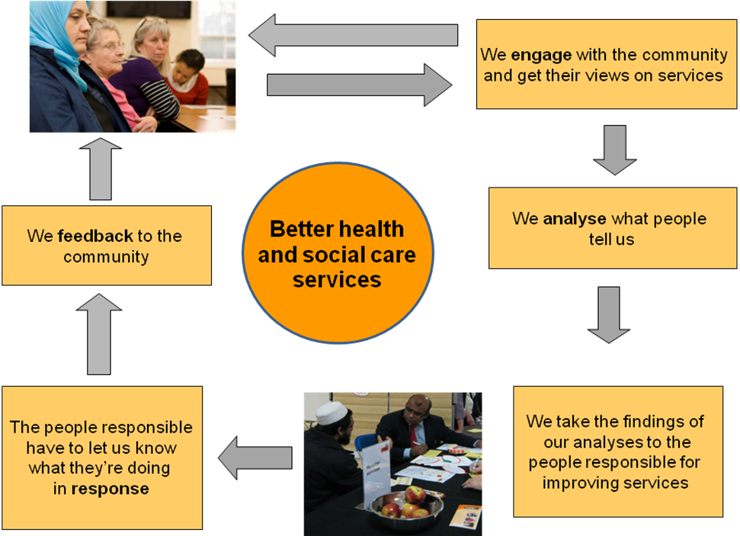  A model structure  The most important part of the THINk structure is its members. THINk firmly believes that:  the users of local health and social care services often have the best ideas and insights as to how they could be improved or made more efficient; and  the only way to come up with effective ways of tackling health inequalities is to engage the wider community in identifying and designing the solutions.  They are therefore designed to engage with a significant number of local people who fairly reflect the experience and views of the local community.
Website | http://www.onetowerhamlets.net/news-1/may_2009/think.aspx

Doctors of the World UK training case study – spotlight on accreditation

Doctors of the World UK has developed curriculum aimed at community groups who are trying to help services users access primary care. A more tailored and technical version is aimed at doctors.
City, country | London, United Kingdom
Organization | Doctors of the World UK
Title of the project | Access to Healthcare Workshops
Source of funding | Private trusts
Short description of the program | Doctors of the World UK has a wealth of frontline knowledge and experience in improving access to healthcare and they have developed a curriculum which helps them pass this on to other organisations.  Workshops help teams develop their knowledge and advocacy skills to better support their service users. The workshop covers rules and regulations with respect to access to health services and will provide you with the tools to advocate effectively on behalf vulnerable clients.  For volunteers, we provide annual training which expands upon this training. CPD credit is available to doctors, barristers and solicitors upon successful completion.
Website | http://www.doctorsoftheworld.org.uk/projectlondon/accesstohealthcareworkdshops.asp

Delivery of healthcare – good practices checklist

Suitability/Quality of care
- Involvement of service users in planning, monitoring and evaluation
- Significant financial commitment and recognition that the issues need to be addressed with a long-term view and solutions need to be sustainable.
- Systemic and period training provided to healthcare professionals

- Polyclinics which enable the service user to have a range of needs addressed (health, social, legal and educational)
- Developing key partnerships that take into account expertise and methods of working, and are sustainable in the long term
- Integration (full or partial, as appropriate) with mainstream healthcare services
- Recognition of the link between health and well-being
- Rigorous external monitoring which is evaluated in a timely manner and exchanged with other actors (NGOs, government, service users) so that experiences can be shared and lessons learnt.

Accessibility of care

- Opening hours which meet the needs of service users
- Central location, easy to reach by public transportation
- Reimbursement for travel expenses
- Provision of interpreting services
- Provision of childcare
- Participatory and multi-cultural approach which takes into account the multiple and diverse origins of the beneficiaries, but also the cultural specificities of each country.

Adopting a community development-based approach incorporating the following key elements: a focus on improving access as an outcome in itself; a focus on user and community empowerment as outcomes; a focus on partnership working across disciplinary and departmental boundaries; a recognition of timescales involved in addressing barriers to effective access to healthcare; and a move away from an emphasis on measurable health outcomes as a short-term objective and success indicator.

Project:London case study
City, country | London, United Kingdom
Organization | Doctors of the World UK
Title of the project | Project:London
Source of funding | Trusts, Foundations and private donations
Contact details | Fizza Qureshi  Fqureshi@doctorsoftheworld.org.uk
Short description of the program | Project: London is an advocacy project, established in 2006 that provides information, advice and practical assistance to vulnerable people to help them access NHS and other services.  Click here to read their reports.  In order to access the most hard-to-reach groups, Project: London's volunteer teams provide basic healthcare in the interim period, until these people reach mainstream service.  Medical staff and support workers are at every session to provide information, advice and practical assistance on how to access mainstream health services. Basic medical healthcare is provided on site.  All of their health professionals are registered with the General Medical Council for doctors, or the Nursing and Midwifery Council for nurses. Most of the doctors and nurses are currently working in the NHS; they choose to volunteer for Project: London in their spare time. The support workers come from different walks of life. Some are medical students, while others work in administration, IT or public health. All the volunteers have received specific training to prepare them to work on Project: London.
Website | http://www.doctorsoftheworld.org.uk/projectlondon/default.Asp

Sandwell PCT dedicated GP practice case study

City, country | Sandwell, United Kingdom
Organization | Sandwell PCT
Title of the project | Dedicated GP service for migrants
Source of funding | Sandwell Primary Care Trust
Short description of the program | In 2001 the Sandwell Primary Care Trust decided to open a General Practitioner practice which was dedicated to migrants. The practice provides access to primary care and has developed a speciality in meeting the needs of vulnerable migrants who may not have an understanding of how the National Health Service functions and may not have the documentation normally required.  Since 2001, the practice has seen the number of registered patients decrease. As a result, the PCT has taken the decision that the dedicated practice is no longer cost-effective and is exploring alternative models, one of which will be implemented in 2011, after public consultation.
Contact details | Martina Ellery - 0121 612 1423  Martina.Ellery@sandwell-pct.nhs.uk

Hetherington Group practice case study

City, country | London, United Kingdom
Organization | Refugee Health Team Lambeth, Southwark, Lewisham
Title of the project | Hetherington Group Refugee clinic
Source of funding | London Borough of Lambeth and Refugee Council
Contact details | Dr. Judith Eling  juditheling@nhs.net
Short description of the program | The Refugee Health Team (RHT) is a multidisciplinary team working across Lambeth, Southwark and Lewisham (LSL) that provides health care to refugees and asylum seekers. Most services are provided at non-NHS venues in partnership with the voluntary sector. The service is designed to address users' multiple complex needs, provided nearer to where people live (day centres, community organisations, GP Practices or NHS centres) or/and in an environment that is convenient and comfortable for them. The team aims to improve access to the NHS for this client group and provides relevant health interventions. The team members share an specialist professional interest in the client group.  The Refugee Health Team LSL objectives are to:  - Identify and address difficulties preventing access to health services by refugees and asylum seekers.  - Reduce the inequalities facing our clients and prevent social exclusion.  - Influence the quality and appropriateness of primary health care services in LSL.  - Ensure that refugees and asylum seekers are able to exercise their rights to NHS services, and are shown respect for their privacy, dignity and religious and cultural beliefs  - Work with Refugee Community Organisations (RCOs) to raise awareness about the NHS and health issues.  Clinical services  Nurse-led clinics for refugees and asylum seekers are run in day centres, NHS centres and voluntary organisation premises and at hostels (resident-only access) across in Lambeth, Southwark and Lewisham.  A holistic health assessment is offered to all services users  Nurses provide treatment and liaise with local NHS services to mainstream clients, provide health advice, information and referrals  A Community Psychiatric Nurse (CPN) makes initial mental health assessments, provides mental health treatment, relevenat interventions and referrals  Provision of GP services, registration and consultation for the most vulnerable asylum seekers and refugees (special innovative project)  Case management is offered according to client needs  Advice and social support  Provision of information and guidance on how to access the NHS and facilitate access to NHS services  One-to-one advice, information, triaging and advocacy sessions delivered by multilingual health workers or/and using interpreting services when necessary  Advice and information on social issues, such as referrals to solicitors, referrals to community organisations, day centres to promote social integration, and guidance on how to deal with social issues affecting their health)  This service is provided across LSL at voluntary agencies and health centres
Website | http://www.threeboroughs.nhs.uk/index.php?PID=0000000198

Further resources

“NHS evidence on ethnicity and health”

This website is a portal to a database of material compiled by the National Health Service which analyses the links between ethnicity and health.
Accessible at http://www.library.nhs.uk/ethnicity/

“Transatlantic Trends – Immigration (2009)” European survey on perceptions of immigration.

This study shows the results of a pan-European study on the perceptions and understandings the people have toward migrants. The authors compare perception to reality, which serves to underscore the gap in perception. Finally the authors seek to explain that gap, in order to point the reader toward finding ways to close it.
Accessible at http://www.gmfus.org/trends/immigration/index.html

“3rd Conference on migrant and ethnic minority health in Europe” – Proceedings of conference

“In our globalized world migration is a multifaceted and complex issue,
which nowadays concerns every country in the World. An estimated more
than 200 million people are living outside their country of origin. Europe as
one of the most preferred target areas for migrants – economically benefits
from this. On the other hand, Europe is struggling with the responsibility
for providing conditions necessary for facilitating their integration and
preventing possible societal and political side effects. Health (care)/ public
health aspects should be considered as priority issues. At the same time
ethnic minorities living in Europe are frequently facing similar problems.
That is why the EUPHA initiative on launching a regular, European level
forum for bringing together researchers, academics, health and social care
professionals and policy makers at EU and country level, is meant to enrich
its 3rd Conference with aspects of ethnic minority health. A review of the proceedings makes it clear that the conference contributes to developing a shared view on values and principles, health needs and adequate responses.
Accessible at http://www.mighealth2010.net/

“European Observatory on Access to Healthcare” European survey on undocumented migrants’ access to healthcare

The results of this pan-European study highlight the difficulty that migrants encounter when they try to access healthcare. The data also paints a clear picture of the health conditions they present with, and the circumstances which make healthy living more difficult.
Accessible at: http://www.doctorsoftheworld.org.uk/lib/docs/121111-europeanobservatoryfullreportseptember2009.pdf

Development of Policy
Although they are UK specific, the following recommendations outline a methodology which could be useful in other contexts.
- Policy makers might consider the following:
- Establish centralised systems of data collection on the health outcomes and service use of people in local areas – for instance, through Primary Care Trust information systems – that wherever possible include ‘migration variables’ (e.g. country of birth, length of residence in the UK, language use, nationality and immigration status) as well as ethnicity and socio-demographic information (recognising that migration data collection can be sensitive).
- Gain information about the health needs of and barriers to health care access and uptake among diverse groups of migrants. This could be done in part through the experiences of statutory and voluntary organisations, those representing different migrant groups in local areas and migrants’ own welfare networks. Primary research that provides evidence on age, gender, socio-economic status, ethnicity, religion, language and country of birth is also important.
- A particular effort should be made, in research and in service provision, to reach those more vulnerable groups who are less likely to register for primary care because of inadequate information or insecure legal status. Places of religious worship, such as churches, mosques and temples, may contribute to effective mapping, particularly of those who do not have a legal immigration status and
- are helped to access services by religious institutions.
- Adopt a community development-based approach incorporating the following key elements: a focus on improving access as an outcome in itself; a focus on user and community empowerment as outcomes; a focus on partnership working across disciplinary and departmental boundaries; a recognition of timescales involved in addressing barriers to effective access to health care; and a move away from an emphasis on measurable health outcomes as a short-term objective and success indicator.

Further resources
There are a number of articles which analyse the policy issues surrounding this group. A few key articles are referenced below:

“Migration and Immigrants Two Years after the Financial Collapse: Where Do We Stand?”

Recessions can take an extraordinary human toll that extends well beyond temporary earnings losses for unemployed workers. Job loss during a downturn is thought to result in long-term employment and wage setbacks, deteriorating health and higher divorce rates, increasing poverty and child poverty, and lower educational attainment for children in low-income areas. These impacts are most troubling for low-income households, which are less well positioned to buffer earnings losses during a recession and which are more likely to fall into poverty as a result.
The impact of the economic crisis has fallen unevenly on demographic groups…Immigrants and their families merit particular attention, since they have often experienced the worst impacts. Young workers, for instance, have faced difficult times over the past two years, regardless of their place of birth — but the impact on young immigrants has been particularly devastating. In 2009, foreign-born youth experienced unemployment rates of 41 percent in Spain, 37 percent in Sweden, and 24 percent in the EU-15. Canada and the United States witnessed immigrant youth unemployment of 20 and 15 percent, respectively. Similarly, men have taken the brunt of recent job losses, particularly immigrant men.
Accessible at http://www.migrationpolicy.org/pubs/MPI-BBCreport-2010.pdf

“Immigrants and Health Care Reform: What’s Really at Stake?”

Examines the impact of legal and unauthorized immigrants on the healthcare reform proposals in the United States. Since lawmakers intend to exclude unauthorized immigrants, the article examines the question of how to exclude them without creating a large and expensive screening bureaucracy, and without imposing difficult verification burdens on citizen and immigrants. This could prove useful as it is based on analysis and imputation of Census Bureau data which provide a portrait of immigrants by legal status, current health insurance coverage, and variations in coverage across large immigrant states. While a different context to Europe, there are many lessons which can be drawn from the American experience.

Accessible at www.migrationpolicy.org/pubs/healthcare-Oct09.pdf.

“Asylum Seekers and the Right to Access Health Care”
In recent years, the issue of access to health care by asylum seekers has raised serious questions for government, the courts and the medical profession. Who has the right to medical treatment in the United Kingdom is a political, humanitarian and human rights matter. For the Government - often facing public hostility towards asylum seekers and migrants, fearful of health tourism or “pull factors” to the UK, and confronting burgeoning financial constraints -, treatment is often regarded as a concession rather than a right. For the courts, any decision to grant treatment to non-nationals, particularly those with no right to remain, is seen as having has political implications far beyond the needs of the individual. The medical profession, by contrast, prefers in the main to focus on the patient, without regard for immigration status, and is uncomfortable with a dual role. Where the balance should lie is currently being assessed by Government as it considers responses to a Consultation Paper on Review of Access to the NHS by foreign nationals. At this timely point, this article offers a multi-disciplinary approach to the question of access to health care by asylum seekers, by examining not only the legal position but also government policy, its impact on the individual, and, significantly, the ethical and philosophical arguments pro or contra treatment. It is contended that only through this comprehensive analysis can an appropriate legislative approach be adopted at a time when this critical social right is gaining ascendance.
Accessible at http://papers.ssrn.com/sol3/papers.cfm?abstract_id=1657946
Author’s contact details: Dallal.Stevens@warwick.ac.uk; +44 2476 523289

Additional studies conducted by esearch think thank on transatlantic migration
Accessible at http://www.migrationpolicy.org/transatlantic/

2005 Communication.
Jeffrey Ring, Ph.D. & Julie Nyquist, Ph.D (2009).
Poverty among migrants remains a real concern. One recent study found that, prior to the recession, cash benefits for low-income households reduced the poverty headcount among Spanish natives by half but reduced the poverty headcount among immigrants by only 5 percent. Rafael Muñoz de Bustillo and José-Ignacio Antón, “From rags to riches? Immigration and poverty in Spain,” Munich Personal RePEc Archive, March 2010, http://mpra.ub.uni-muenchen.de/13848/.
Demetrios G . Papademetriou, Madeleine Sumption, and Aaron Terrazas with Carola Burkert, Stephen Loyal, and Ruth Ferrero-Turrión (2010).
Capps, Randy, Marc R. Rosenblum, and Michael Fix (2009).
Dallal Stevens (2010)

