Healthy and Wealthy Together

AGENDA 1st Steering Group Meeting-
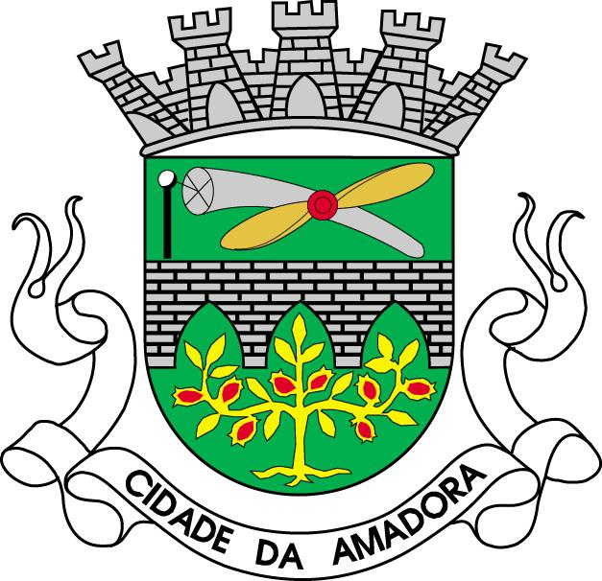

AMADORA
BIRMINGHAN
MILANO
BRON
piacenza
belfast
ROQUETAS DE MAR
ANO LIOSSIA

With the
support of:
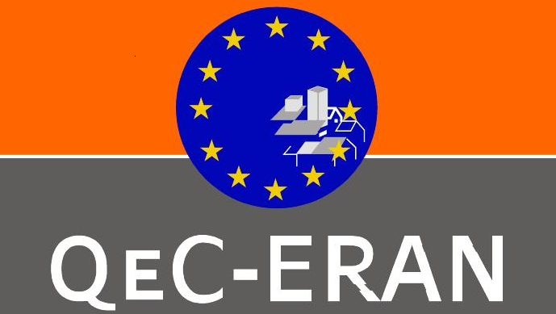



Brussels, February 4th to 5th 2010

Venue: QeC-ERAN Office,
Rue Vieux Marché Aux Grain 48, 1000 Brussels
Tel: +32 (0)2 524 45 45
Fax: +32 (0)2 524 44 31

Thursday 4th February 2010

Hotel Atlas, Rue du Vieux Marché aux grains 30, 1000 Brussels
Phone: + 32 (0)2 502 60 06, Fax: + 32 (0)2 502 69 35
Web: www.atlas.be

16:00 | Introductions and Welcome  Workshop and Brainstorming in between the Partners
18:30 | End of the Session
20: 30 | Dinner at Divino  Rue des Chartreux, 56 Tél. : +32 2 503 39 09

Friday 5th February 2010

9:00 | Overview of the project presentation followed by questions and discussion
10:00 | Management and Co-ordination, including Budget and Financial Management
11:00 | Tea/Coffee Break
11:30 | Local action group and local mapping
12:00 | Project management platform. Presentation of Qec-ERANlive
13:30 | Standing Lunch
14:45 | Experiences and activities: presentations by the Partners
16:15 | Agreed Actions: planning next steps
17:00 | Any Other Business
17:30 | Close of Steering Group Meeting
20:30 | Dinner  La Cantina Cubana  6 - rue des Grands Carmes - 1000 BruxellesTel. 02.502.6540

