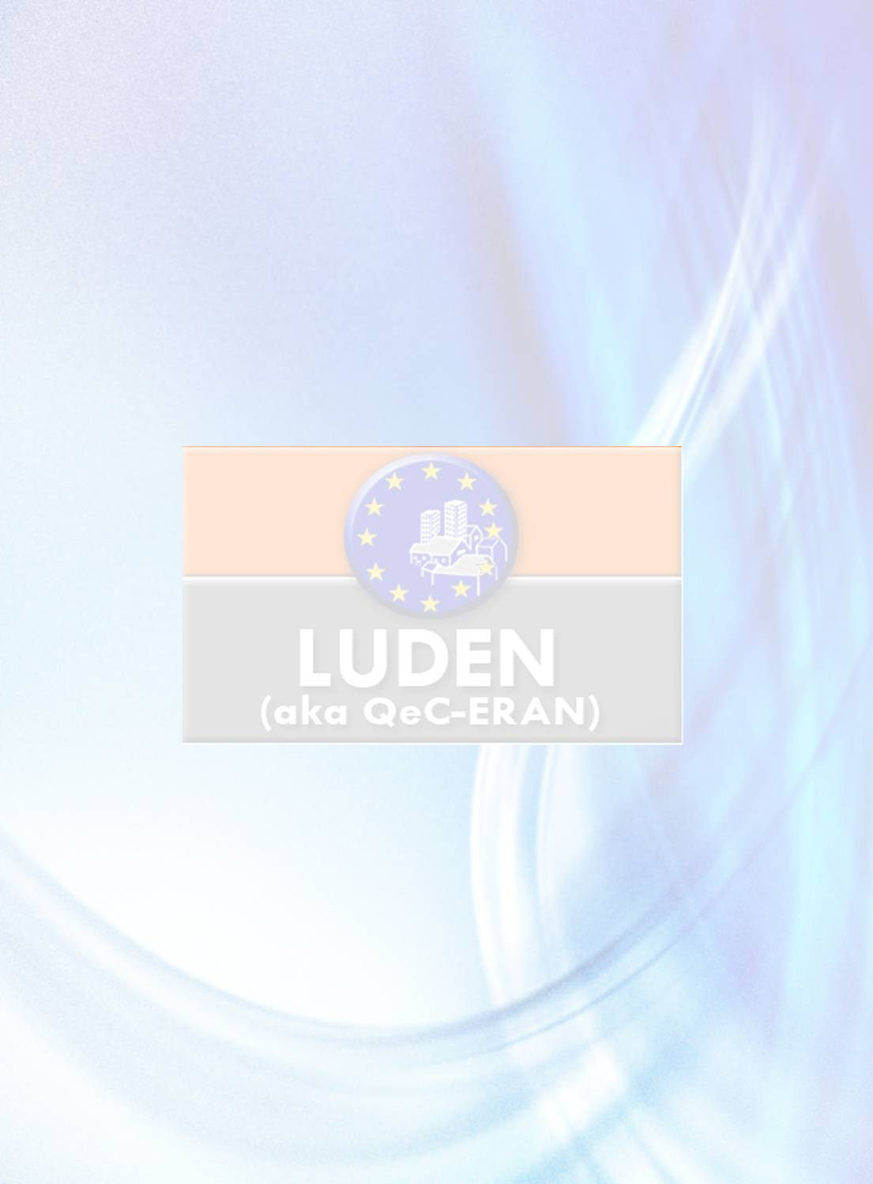
Second Transnational Exchange Workshop

22 – 25 May 2012, Timisoara, ROMANIA

^{List of participants}

Name | Email | Partner
1. Ms. Ana Teresa Lampreia | tlampreia@cm-sintra.pt | Municipality of Sintra (PT)
2. Ms. Anabela Paraiso NunesCosta | aparaiso@cm-sintra.pt | Municipality of Sintra (PT)
3. Mr. Jorge Miranda | jorge.miranda@slbenfica.pt | Etnoideia , Sintra, Portugal
4. Ms. ADAMANTIA MAVROMATI | mavromati-m@heraklion.gr | Heraklion Municipality (EL)
5. Ms. Zacharenia Drosou | drosou@heraklion.gr | Heraklion Municipality (EL)
6. Ms. Manouela TSATSAKI | tsatsaki-m@heraklion.gr | Heraklion Municipality (EL)
7. Ms. Eva Benková |  | European Development Agency, Ltd. (CZ)
8. Mr Martin Synkule | martin.synkule@eracr.cz | European Development Agency, Ltd. (CZ)
9. Ms. Helena Cerna |  | European Development Agency, Ltd. (CZ)
10. Ms. Filová Božena |  | European Development Agency, Ltd. (CZ)
11. Ms. Romina Matei | romina.matei@intercultural.ro | Intercultural Institute Timisoara (RO)
12. Mr Daniel Spataru |  | Intercultural Institute Timisoara (RO)
13. Mr Facalet Victor |  | Intercultural Institute Timisoara (RO)
14. Mr Calin RUS | calin.rus@intercultural.ro | Intercultural Institute Timisoara (RO)
15. Mr Eugen Gherga | Eugen.Gherga@intercultural.ro | Intercultural Institute Timisoara (RO)
16. Ms. Ramona Facalet |  | Intercultural Institute Timisoara (RO)
17. Ms. Corina Fenichiu | Ccdf98@yahoo.fr | Intercultural Institute Timisoara (RO)
18. Mr Bucse Sandu | avoncoordbucse@yahoo.com | Intercultural Institute Timisoara (RO)
19. Ms. Ionita Amalia | Ionita.amalia.elena@gmail.com | Intercultural Institute Timisoara (RO)
20. Mr Jurca Ioan | Jurca.ioan51@yahoo.com | Intercultural Institute Timisoara (RO)
21. Ms. Daniela Craciun |  | Intercultural Institute Timisoara (RO)
22. Ms. Alina Ardelean |  | Intercultural Institute Timisoara (RO)
23. Ms. Cornelia Kirali |  | Intercultural Institute Timisoara (RO)
24. Ms Letitia Mark |  | Intercultural Institute Timisoara (RO)
25. Mr Rudolf Stancu |  | Intercultural Institute Timisoara (RO)
26. Ms. Ramona Gherman |  | Intercultural Institute Timisoara (RO)
27. Ms. Genoveva Drumeva | drumeva_gevi@abv.bg | Dobrich Municipality (BG)
28. Ms. Daniela Petrova Milkova | d_milkova@dobrich.bg | Dobrich Municipality (BG)
29. Ms. Kamelia Koicheva Jordanova |  | Dobrich Municipality (BG)
30. Ms. Sorina Andrea Toma | sorina.toma@hotmail.com | Belfast Health and Social Care Trust, (UK)
31. Ms. Alexandra Mc Carry | sandra.mccarry@belfasttrust.hscni.net | Belfast Health and Social Care Trust(UK)
32. Mr Stephen Long | stephen.long@belfasttrust.hscni.net | Belfast Health and Social Care Trust(UK)
33. Ms. Cezara David | Cezara@romanicriss.org | Romani CRISS, Bucharest (RO)
34. Mr Vasile Gilbea | vasile@romanicriss.org | Romani CRISS, Bucharest (RO)
35. Mr Sorinel Dimitru | sorin_dumi9@yahoo.com | Bucharest (RO)
36. Mr Ian Poitier | ian@firebrandfilms.co.uk | Expert, campaign specialist
37. Ms. Caroline Sykora | caroline.sykora@gmail.com | Expert consultant for Eurochild &World bank
38. Ms. Cécile Gracy | c.gracy@ludenet.org | LUDEN (BE)
39. Mr Haroon Saad | h.saad@ludenet.org | Director, LUDEN (BE)
40. Ms. Morgane Lassaux | m.lassaux@ludenet.org | LUDEN (BE)

