**I am Roma**

**“Developing local campaigns to challenge negative stereotypes”**

**Final Meeting**

**Date: 28-30 January 2013**

**Place: Brussels**

**Agenda and info pack**

**Monday 28 January**

|  |
| --- |
| **10h-12h** |

**Arrival of delegates**

|  |
| --- |
| **12 :45-14 :15** |

**Lunch at LUDEN Office**

|  |
| --- |
| **14 :30-17 :30** |

**Steering group meeting** Venue: LUDEN OFFICE

|  |
| --- |
| **18:00-20:00** |

**Informal networking event.** Représentation de Provence-Alpes-Côte d’Azur à Bruxelles. 62, rue du Trône B-1050 Bruxelles

|  |
| --- |
| **20h30** |

**Dinner at Divino Restaurant**

**Tuesday 29 January**



***Venue:* Committee of Regions**

**Rue Belliard 99-101, B-1040 Brussels**

**Room JDE 51**

**Programme**

*Moderator: Dr Haroon Saad, Director of LUDEN*

08:45 – 09:30

Registration

09:30:

Welcome and introduction, by Sintra Municipality

09:40:

Setting the context

* An overview of the Project I AM ROMA - Dr. Haroon Saad, Director, LUDEN

10:00:

* The EU Framework for national Roma integration strategies- an update on current state of play and development - Ms Jana Balazova, Policy Officer DG JUSTICE, Unit D4 - Non discrimination policies and Roma coordination

10:30:

Coffee break

|  |
| --- |
| 11:00 |

Case Study One: Advocacy and Public campaign. Romani CRISS

* Oana-Luiza Mihalache, Roma Center for Social Intervention and Studies, Romania
* Ioana Stoicescu, Roma Center for Social Intervention and Studies, Romania

|  |
| --- |
| 11 :25 |

Case Study Two: School students propose solutions to the Roma problems. Intercultural Institute of Timisoara

* Romina Matei, Intercultural Institute Timisoara, Romania
* Ion Goracel, Intercultural Institute Timisoara, Romania

|  |
| --- |
| 11 :50 |

Case Study Three: Fashion and Children’s Movie. Municipality of Sintra

* Jorge Miranda, Etnoideia, Portugal

|  |
| --- |
| 12:15 |

Case Study Four: Festivals, Research and Schools. Municipality of Heraklion

* Mrs Zacharenia Drosou, Municipality of Heraklion, Greece

|  |
| --- |
| 12:40 |

Case Study Five: Community Development. Belfast Health and Social Care Trust

* Stephen Long, Belfast Health & Social Care Trust, United Kingdom
* Alexandra McCarry, Community Development, Belfast Health & Social Care Trust, United Kingdom

|  |
| --- |
| 13:05 |

Lunch

|  |
| --- |
| 14:15 |

Reflections:

* Mr Juan De Dios Ramirez-Heredia, President of Union Romani, former MEP
* Mrs. Paula Simões, Counsellor for Social Affairs, Municipality of Sintra
* Mr Georgios Aerakis - Deputy Mayor of European Programs of Municipality of Heraklion

|  |
| --- |
| 15:00 |

Case Study Six: Working with Children. European Development Agency, Prague

* Martin Synkule, European Development Agency, Czech Republic
* Eva Benkova, European Development Agency, Czech Republic

|  |
| --- |
| 15:25 |

Case Study Seven: Participation and Education. City of Dobrich

* Kameliya Koycheva, Vice Mayor and project coordinator, Dobrich Municipality, Bulgaria
* Daniela Milkova, Dobrich Municipality, Bulgaria

|  |
| --- |
| 15 :50 |

Campaigning to change negative mindsets. Ian Poitier, external expert.

Interactive session with introduction of the toolkit that the project has developed

|  |
| --- |
| 16:45 |

Conclusions

|  |
| --- |
| 17:00 |

End of workshop

|  |
| --- |
| 20:30 |

Dinner at Kokub

**Wednesday 30 January**

|  |
| --- |
| **09 :30-12 :00** |

Venue: LUDEN Office

Bilateral meetings with partners as required

**Info pack**

# 1. ACCOMMODATION

The partners have been booked a room at the Atlas Hotel.

|  |
| --- |
| hostel atlas pix2 |
|  |
| Rue du Vieux Marché aux Grains 30  1000 Bruxelles  0032 (0)2 502 60 062,  <http://www.atlas-hotel.be/> |

**How to reach the Hotel Atlas**

**Airports**

**From Zaventem Airport**

**Take the train at the last floor of the airport which will drives you to the center of Brussels. Stop at “Gare Centrale” station. Then switch to the metro (indicated with a white M on a blue square) and take Metro line that goes to “Gare de l’Ouest” (Line 1) and “Erasme” (Line 5) which are on the same side and track. Stop two metro stations after, at Sainte-Catherine. Out of the metro station, head toward the church and take on your right. Cross the plaza and keep walking. You will cross two streets (Rue de Flandres and Rue Antoine Dansaert ). Atlas hotel is 50 meters after the second cross, on your left-hand side.**

**From Charleroi Airport**

**Take the bus that drives you to Gare du Midi in Brussels. Then switch with to the tramway 3 (direction Esplanade) or 4 (direction Gare du Nord). Stop five tram stations after, at “Bourse”. Take the exit on Auguste Orts street and walk up to the next crossroad. Keep on walking on this street that is now called Antoine Dansaert Street. Keep on walking up until the next crossroad, and take on your left-hand side. Hotel Atlas is 50 meters after on your left.**

**Railway stations**

**From Gare du Midi**

**Tramway 3 (direction Esplanade) or 4 (direction Gare du Nord). Stop five tram stations after, at “Bourse”. Take the exit on Auguste Orts street and walk up to the next crossroad. Keep on walking on this street that is now called Antoine Dansaert Street. Keep on walking up until the next crossroad, and take on your left-hand side. Hotel Atlas is 50 meters after on your left.**

**From Gare du Nord**

Tramway 3 (direction Churchill) and 4 (direction Stalle), s**top four tram stations after, at “Bourse”. Take the exit on Auguste Orts street and walk up to the next crossroad. Keep on walking on this street that is now called Antoine Dansaert Street. Keep on walking up until the next crossroad, and take on your left-hand side. Hotel Atlas is 50 meters after on your left..**

# 2. VENUES AND DIRECTIONS

**Directions from the hotel to Divino Restaurant**

Dinner on 28 January has been booked for 20:00 pm at Restaurant Divino, Rue des Chartreux, n°56 ; Tel: +32(0)2.503.39.09

From the hotel entrance, take on your left and walk on LUDEN’s office direction. Walk out until the next crossing where the dog statue is, and take on your right, on Rue des Chartreux. Walk 100 meters, the restaurant is on your left-hand side.

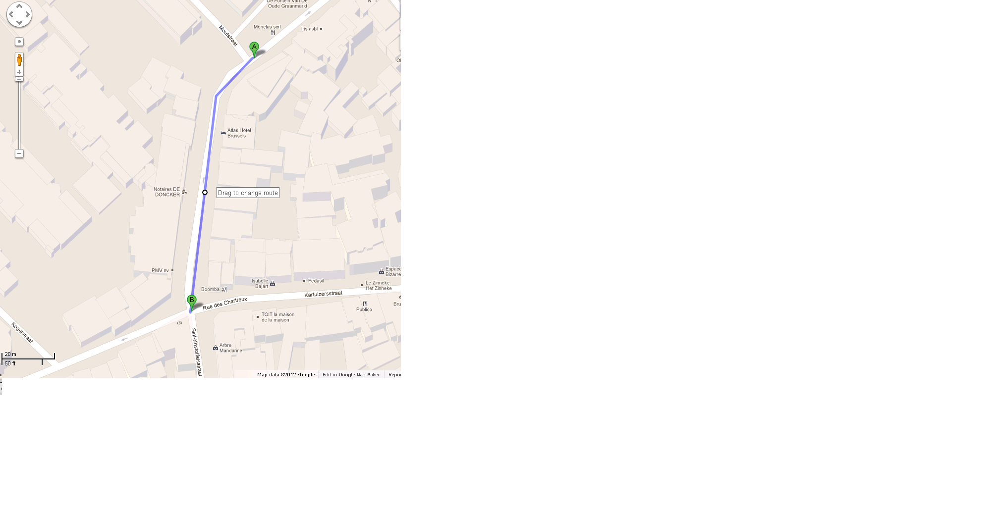

**Directions from the hotel to Kokub Restaurant**

Dinner on 29 January has been booked for h 20:30

at Kokub, Rue des Grands Carmes, 10 - 1000 Bruxelles.

From the hotel, head southwest on Rue du Vieux Marché aux Grains toward Rue de la Braie/Moutstraat.

Continue onto Rue Saint-Christophe

Turn left onto Rue des Riches Claires/Rijkeklarenstraat

Turn right onto Anspachlaan/Bld Anspach

Turn left onto Bijstandstraat/Rue de Bon Secours

Turn right onto Rue du Marché au Charbon/Kolenmarkt

Turn left onto Rue des Grands Carmes/Lievevrouwbroerstraat

The Restaurant will be on the left

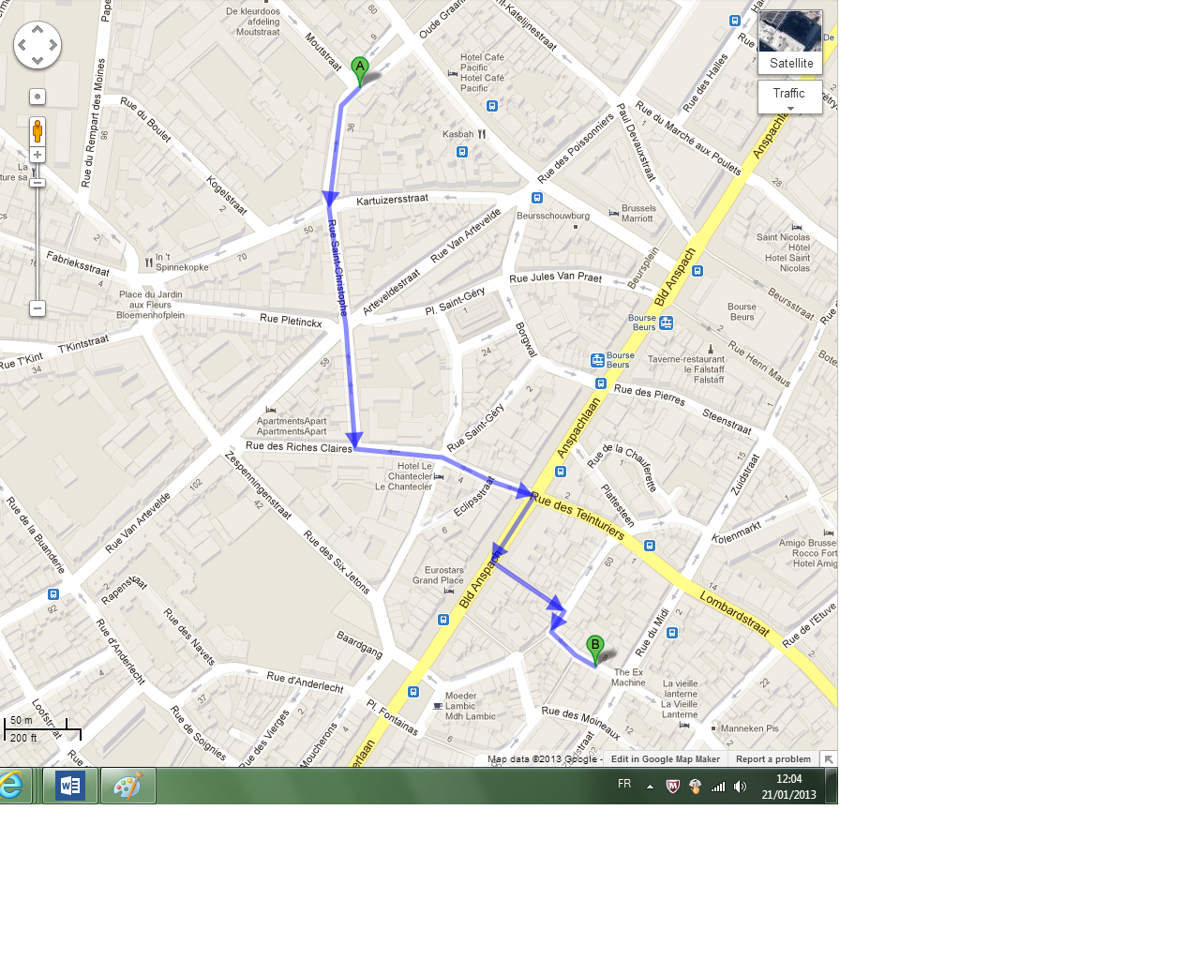

**Directions from the hotel to the Committee of the Regions**

From the hotel, walk to Sainte-Catherine. Take subway 1 towards Stockel or 5 towards Hermann Debroux.

Stops at Maelbeek (5 stops after)

Walk to Rue Belliard 99

(Head west on Rue de la Loi/Wetstraat/N23 toward Rue de Trèves/Trierstraat

Turn left onto Rue de Trèves/Trierstraat

Turn left onto Rue Belliard/Belliardstraat)

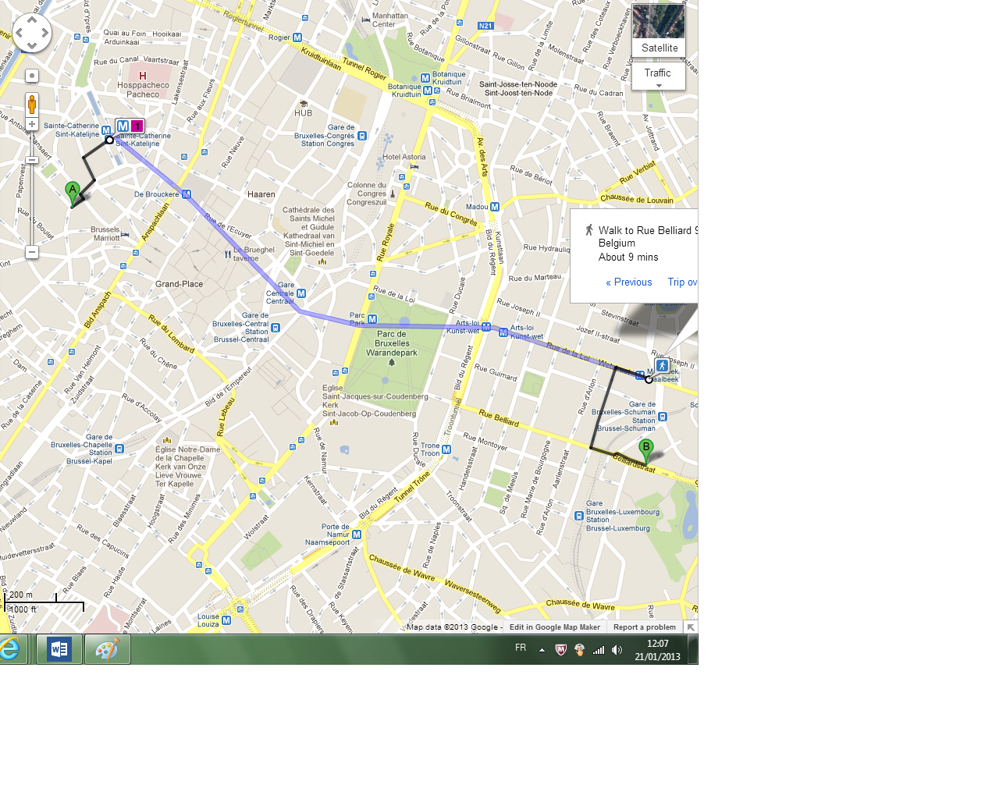

**Reimbursement of travel costs**

Members are expected to either book and pay their flights/travel themselves or ask LUDEN to book them.

The costs will be reimbursed to the members later by LUDEN. Please note that in order to be reimbursed, the travel costs cannot exceed the maximum amount allowed.

Please note that if your flight arrives to Charleroi airport you are required to buy by yourself the bus ticket from the airport to the city centre. Tickets are sold outside the airport terminal and cost 13 Euros.

In order to receive the reimbursement for your travel expenses, please send LUDEN office the following:

Flight expenses - invoice (original); ticket(s) photocopy; original boarding passes, the ones you receive after having check-in at the airport

Train/buses etc. - invoice (original); original ticket(s)

Others (snacks, coffees, etc.) - original invoice(s)

In addition, you will be provided a reimbursement form to fill in SIGNED AND STAMPED.

***We are looking forward to welcoming you all in Bruxelles!***