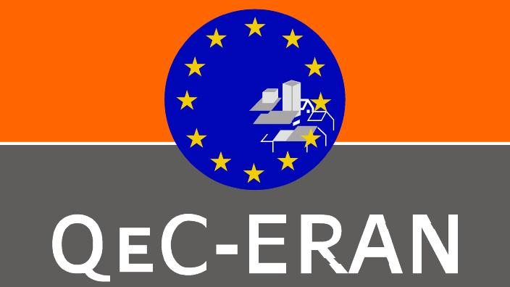 | OPEN DAYS OFF: WHAT IS TO BE DONE?:FIXING THE PRESENT AND THE FUTURE
Tuesday 6 October 2009 - 18.00-24.00
Beursschouwbourg, Rue Auguste Orts Nr 20-28, 1000 Brussels
After your working day, why not come to the QeC-ERAN OPEN DAYS OFF: INSTIGATE AND DEBATE. - Café style debates followed by a party? The overall theme this years debates are the ramifications of the biggest recession since the 1930’s.  18:00 Doors open with a nice aperitif and some tapas after the marathon of power point presentations that you will have sat through or just the normal buzz and hum of your working day.  19:00 Welcome and Introductions to the INSTITIGATE AND DEBATE approach to café style debates  19:15 Debate One: Cities and the Crisis. Chance to discuss and pose questions to a panel with representation from The EP Intergroup on Urban Policy and Housing, Brian Field, Director form the European Investment Bank and Prof. Frank Molleart from the University of Louvain and Co-ordinator of the FP7 platform on Urban Policy and Social exclusion  19:15 Debate Two (yes at the same time): Green Shoots in the third sector: Speakers from European Micro-finance Network, Urbact programme  20:15 Debate Three: What can the European Parliament do? Here the panel will be political representatives from a number of the |  | political groups in the EP. Has the crisis weakened the EP or does it offer an opportunity to show citizens the importance of pan European working? What can/should the EP do? We have invited representatives from some groups to participate: Rebecca Harms – Greens/European Free Alliance (tbc), Mr Swoboda - SDP, (tbc) Jan Olbrycht EPP(tbc)  21:30 -11:00 Party Time  11:00-11:45 Chill and chat to jazzy sounds  This is not an event for those wishing to simply listen. The INSTIGATE AND DEBATE approach will mean that participants will discuss amongst themselves at “virtual tables” and from these discussion generate one or two questions for the panel. We will be also collecting short vox pops from participants relating to the themes of the debates. The participants (you) are the most important ingredient in our menu.  We will of course be providing you with food and drink that will reflect the diversity of Europe. There will be no charge but in the spirit that we wish to create we encourage you to bring something (food or drink) to “put on the table” and create the informality we seek.  Please note the event is only open to 160 delegates  and registration is compulsory.  Please register by sending email to: s.ruissalo@qec-eran.org  English and French will be the working languages for the debates

