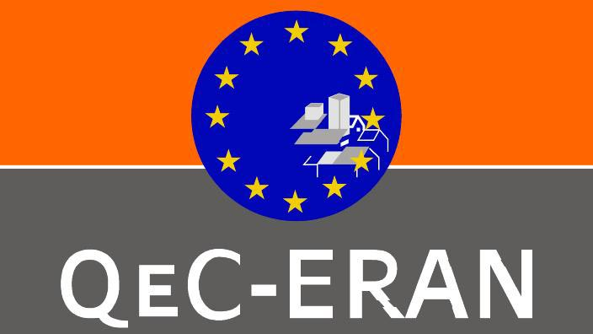
“Skills for Sustainable and Competitive Urban Development” conference, Committee of the Regions, 22 May 2007, - RECOMMENDATIONS

The following recommendations emerged from the workshop on “Skills for Sustainable and Competitive Urban Development” as well as from the “SKILLS AND TRAINING AUDIT” undertaken by QEC -European Regeneration Areas Network (QeC-ERAN) which involved over 200 actors in Urban Regeneration:

- The experience emerging from 16 years of Urban Regeneration practice through the EU URBAN and UPPs programmes have highlighted the need for developing the skills of actors from a variety of sectors and levels in relation to sustainable placemaking. Economic and social regeneration requires new paradigm principles and frameworks. As raised in Leeds, this means in part a greater focus on participation, empowerment, capacity building social and human capital. Such a paradigm focus requires a range of new or “additional skills/experiences” for actors on the ground.

- Relatedly, there is a need to rethink the way in which the transnational exchange of experience and learning can be delivered. The Urbact programme along with Interreg has generated over 80 networks of partners engaged in the transfer of learning and experience. The main vehicles for such programmes have been two/three day transnational workshops as the means for undertaking such a transfer of learning and experience. Whilst , there is a need for “face-to- face “ learning environments it is clear that the impact of all this activity has been marginal in terms of national or local levels. Furthermore such programmes have suffered from being top downward driven. The conceptualisation of the programmes is undertaken at Ministerial /EU level with input from national and EU players. The project proposals are in turn evaluated and approved by national and EU level representatives. Furthermore, far too often the participants in the programmes are not the right people. This is an important point as the core aim is to support an integrated approach. This requires greater cross-sectoral involvement and greater diversity across professions and local actors. In terms of the transfer of learning there is a need for a multifaceted approach which differentiates needs and provides a range of learning methods (online ;peer review workshops; peer to peer learning; research; short term secondments ; summer schools etc). In particular there is a need to harness latent potential and knowledge through an action-learning methodology that combines experiential learning along with reflective and capacity building/empowerment components.

- The Skills agenda has to link into the broad goals of Lisbon and Gothenburg as well as the revised Strategy for Growth and Jobs. More specifically in the following programming period(2007-13) there is a need to build better linkages into key EU programmes such as “Regions for Change”; European Employment Strategy; European Social Inclusion and Protection Strategy; Life Long Learning Strategy etc. From such a policy context such there are three broad areas that need to be addressed:

  - Skills linked to effectively supporting the broad agenda ( Lisbon; Gothenborg etc);
  - Skills linked to specific challenges( Integration and Migration; Reducing CO² omissions; Demographic ageing; Activation for Work and Enterprise etc)
  - Skills for capacity building linked to the generic skills underpinning the Bristol Accord

- Relatedly, the Skills agenda has also to take into account organisational learning. Far too often the impact of individual learning is lost as a result of organisational incapacity or lack of flexibility/creativity. This results in the often cited gap between “know-how” and “can-do” skills within key mainstream organisations.

Specific recommendations resulting from the “Skills and training audit”:

- In terms of generic skills on average 42% of respondents of the skills audit indicated that they had some further training needs in relation to the nine sub-skills grouped in the Strategic Skills cluster. Just over 36% of respondents indicated that they had considerable training needs. In terms of the Practical Skills cluster, 61% of respondents indicated some further training needs and just under 18% indicated that they had considerable training needs. Finally in relation to process skills 70% of respondents indicated some further training needs and just under 14% indicated that they had considerable training needs.
- The importance of generic skills has also been highlighted through the one to one interviews. A number of areas of work clearly emerge in terms of these generic skills:
  - Partnership working
  - Project Management
  - Leadership
  - Building stakeholder relationships
  - Team working
  - Analysis, decision making skills
  - Community Engagement
  - Creative thinking
  - Financial management
  - Communication
  - Conflict resolution
  - Customer awareness / feedback
  - Process/change management

- The responses also indicate that the skills gap are widest for conflict resolution, building stakeholder relationships, and analysis and decision-making. Community engagement, communication, partnership working and creative or innovative thinking also have relatively wide gaps between the level of importance and the perceived level of competency.
From the albeit small sample of one to one interviews it is also possible to extrapolate that senior staff rated partnership working most highly and conflict resolution least highly; and the project staff rated community engagement most highly and process/change management least highly. Relatedly, in general senior staff rated generic skills more highly than project staff. This supports the work commissioned by English Partnerships, which stated that senior staff rated generic skills as more important than technical skills for delivering successful regeneration; whereas less senior staff thought that technical skills were more important.
- The survey also highlights that generic skills are considered essential for delivering successful regeneration. However, those that work in regeneration state that their competency levels are not sufficiently high. This suggests that if sustainable communities are going to be achieved, those that work in regeneration, staff at all levels, will have to develop their generic skills.

- In respect to professional knowledge skills, these were grouped into two broad categories. One dealing with EU programmes and policies and the second focussing on issues in contemporary urban issues. Overall just over 70% of respondents indicated a need for training/briefing in relation to EU policies and programmes relating to Education and Culture; Cohesion/Regional policy and Employment Strategy. Just over 86%indicated such a need in relation to Social and Employment policies and programmes. These programmes are more “people/group” focussed and this high need highlights the fact that regeneration programmes have had the greatest difficulty in impacting in relation to these “softer issues”
- In terms of issues in contemporary urban issues just under 69% is the average level of need indicated. The issues of Neighbourhood Governance (86%); ICT(78%); Enterprise development(74%); Integration of minorities(73%) have higher levels of need than the general average indicated.
- What this element of survey therefore highlights is the relatively weak interconnection between key EU policies and programmes and urban regeneration programmes at a local/regional level. Whilst there is expertise regarding rules and procedures relating to EU programmes, there is gap in relation to setting and understanding these programmes and policies within a local context. This finding suggests why one of the weaknesses of transnational exchange programmes has been the ability make such a link between EU strategies and national/regional/local strategies.

- The preferred method of training (83%) for respondents were short, accredited courses that ran over a number of weeks.61% or respondents also expressed an interest in on-line learning. The internet is the most common learning resource(85%) followed by 60% of respondents who found case studies to be good learning resources. In terms of barriers to taking up training, lack of awareness (91%) and lack of time (66%) were the key barriers. The issue of funding was also mentioned frequently in the one to one interviews.

In conclusion the Skills audit highlighted the gap between the policy aspiration of “sustainable and competitive communities” and the skills of actors responsible for delivering regeneration programmes.

The findings suggest the need to develop a generic skills development programme which consists of the following elements:
- Partnership working. This includes specific public- private partnerships as well as partnerships which involve all local stakeholders.
- Leadership
- Community engagement. All respondents saw community engagement as vital to effective regeneration but in the one to one interviews it was also reported that it has not been effectively undertaken.
- Conflict resolution
- Building stakeholder relationships
- Analysis and decision making

This is not an exhaustive list but reflects the priorities emerging from the survey.

