
INFORMATION PACK

QeC-ERAN Members Workshop:
Skills for sustainable and competitive urban development: Taking the EU agenda forward
22 May 2007, Committee of the Regions, Brussels

- ACCOMMODATION

The QeC – ERAN workshop participants will stay at the HOTEL ATLAS in the city centre. A single room for each participant has been booked for 1-2 nights depending on the registrations (arrival 21th and departure 22nd or 23rd of May).

The accommodation costs (including breakfast and taxes) will be covered directly by QeC-ERAN as usually for one delegate/member.

Please keep in mind that all the extra (bar, telephone, pay tv, extra services, etc) will be on your charge.

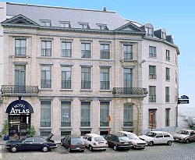
2. HOW TO REACH THE HOTEL ATLAS ?

Address:

ATLAS HOTEL Brussels ***
Rue du Vieux Marché aux Grains, 30
B - 1000 Brussels - Belgium
Phone : +32 (0)2 502.60.06 - Fax : +32 (0)2 502 69 35
Email us: info@atlas.be - Visit us: www.atlas.be

If you are coming by airplane to the Brussels International Airport:
From the airport you can reach the centre by direct train (2.80€) to Central Station. There is a train approx. every 15 minutes and the journey time is 20-25 min. Taxi costs approx. 35€.

From Central Station: Take the line 1A-direction “Roi Baudouin” or the 1B-direction “Bizet” and step out at St.Catherine metro station. Please see the map on the page 4.

If you are coming by train the easiest way is to continue to the Central Station and take the metro from there to St. Catherine. In case you need to get off at Gare du Midi Station, take the tram (3, 52, 55, 56 or 81) to La Bourse (1.40€). From there follow the street in front of the Bourse, which becomes Rue Antoine Dansaert after the intersection. The hotel is located on the second street on the left. Please see the map on the page 4.

If you are coming by car: Please see the map on the page 4.
- RESTAURANTS

At arrival - on 21 May 2007 at 20.00pm

"I Latini"
Ristorante
Cuisine gastronomique italienne.
Salle pour réceptions et séminaires.
1a & 2 place Sainte-Catherine, 1000 Bruxelles
Tél: +32 (0)2 502 50 30
Fax: +32(0)2 502 56 03

After the conference - on 22 May at 20.00pm

“Restaurant La Manufacture”

Rue Notre Dame du Sommeil 12-20
1000 Bruxelles
Tél: +32(0)2 502 2747
Fax: +32(0)2 502 2715
www.manufacture.be

Meeting point in both evenings is at the HOTEL ATLAS lobby at 20.00pm. If you are for some reason arriving later, please come directly to the restaurant. Both restaurants are very close to the hotel, so you can easily reach them. Please see the map on the page 4.

- VENUE & THE MEETING


Committee of the Regions
Rue Belliard, 101
B - 1040 Brussels - Belgium
Tel. (32-2) 282 2211

Conference: Skills for Sustainable and Competitive Urban Development
Date: 22 May 2007
Venue: Committee of Regions, Rue Belliard
Time: 09:00-17:30

Please note that you will need to prove your identity when entering the Committee of the Regions, so please take the necessary documents with you (passport, identity card etc.).

Please also reserve enough time for the registrations and the journey to the venue.

How to reach the venue from the hotel?

By METRO:
Take the metro from St. Catherine (metro sign next to the church).
Take the line 1A (direction: Hermann-Debroux) or 1B (direction: Stockel) and step out at Maalbeek.

In Maelbeek choose the exit - > Rue de la Loi. When you are outside turn left; take the next street left “rue de Tréves”, continue straight until you reach the street “rue Belliard” and take it left.

The CoR is located in Rue Belliard on the right hand side directly after the European Parliament.

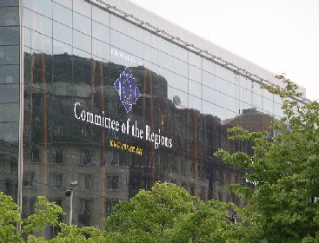

5. MAP OF THE HOTEL AND RESTAURANT AREA

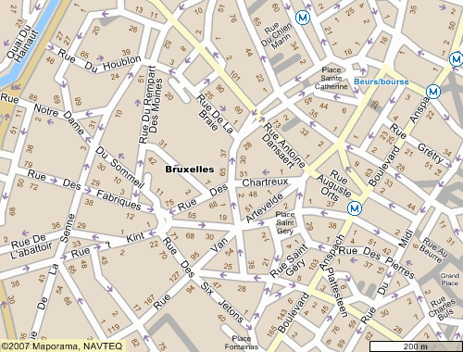
Metro St. Catherine

Restaurant I LATINI

Hotel Atlas – Rue Vieux Marchè aux Grains 30

QeC-ERAN Office - Rue Vieux Marchè aux 48

Restaurant La Manufacture - Rue Notre Dame du Sommeil 12-20

Map of the Region Brussels :

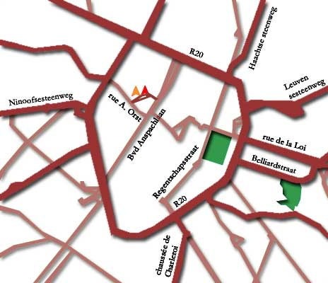

Pl. St. Catherine

Venue : Committee of the Regions

6. LINKS OF INTEREST DURING YOUR STAY IN BRUSSELS

Brussels Airport
http://www.brusselsairport.be/

Charleroi Airport
http://www.charleroi-airport.com/

Metro and Bus
http://www.stib.irisnet.be/

Train
http://www.b-rail.be/main/E/index.php

City Map
http://www.trabel.com/brussels-mapslist.htm

Brussels Tourism
http://www.brusselstourism.com

7. CONTACT DETAILS

If you have any questions or problems you can contact us at the office:

QeC-ERAN
European Regeneration Areas Network,
Rue Vieux Marché Aux Grains 48, B-1000 Brussels
Tel: +32 (0)2 524 45 45, Fax: +32 (0)2 524 44 31,
E-mail: info@qec.skynet.be, www.qec-eran.org

Or outside office hours you can contact :

Haroon Saad +32 (0) 498 123 403
Minna Riutta + 32(0) 484 142 124

